Lei Li and Patrick C. Wilson

WILSON LAB@ uCHICAGO

Librator V 1.0 - User manual

Table of Contents

Installation 2

System requirement 2

Install Librator 2

Install - essential dependencies 2

Install - optional dependencies 2

Run Librator 3

User interface 5

Main Tab (printable) 5

Sequence Tab (printable) 6

Alignment Tab (HTML) 7

Sequence DB Tab 7

Sequence Logo Tab 8

Summary Tab 9

Summary Tab (HTML) 9

Fragment DB Tab 10

Functions - basic functions: 11

Path setting 11

Create new sequence database 11

Open existing sequence database 12

Import sequences 12

Export sequences 12

Functions - advanced functions: 14

Edit sequence information (on Main tab) 14

HA numbering system 15

Identify mutations 16

Multiple sequence alignment 17

Generate phylogenetic tree (ML tree) 18

Generate sequence Logo (peptide/nucleotide conservation) 20

Mutate sequence 20

Compare sequences and generate screening mutations 21

Epitope transplant across different subtypes 22

3D visualization via PyMOL 23

Generate Standardized Gibson Clone fragments for HA/NA in batches 24

Generate Gibson Clone fragments for any sequence 26

Identify possible key residues from two groups of sequences 26

Contact 27

# Installation

### System requirement

Librator requires MacOS 10.13 or higher version.

Librator was compiled under MacOS 10.14 and has been tested on MacOS 10.14 and MacOS 10.15.

### Install Librator

Drag and drop Librator to application folder.



### Install - essential dependencies

The two aligners are required by most core functions of Librator. We already included pre-compiled ***clustal omega*** and ***muscle*** with Librator. In case our versions are not compatible with your MacOS versions, please see below for details.

***Clustal Omega***

If our version doesn’t work on your computer, please download clustal omega from <http://www.clustal.org/omega/> and then setup the correct path in path setting (see basic function->path setting for details).

***Muscle***

If our version doesn’t work on your computer, please download muscle from <https://www.drive5.com/muscle/> and then setup the correct path in path setting (see basic function->path setting for details).

### Install - optional dependencies

Here are some optional dependencies. Most of core functions of Librator are still working without those tools.

***PyMOL*** (<https://pymol.org/2/>) (highly recommend!)

PyMOL for 3D structure visualization of proteins

Download from official website (license required after 30 days free trail)

or install from anaconda

conda install -c schrodinger pymol

or install from homebrew (recommended )

brew install brewsci/bio/pymol

or install from MacPorts

sudo port install pymol

or install from source ( not recommended )

python setup.py --osx-frameworks install

After you installed PyMOL and setup the correct path (see basic function->path setting for details), Librator is ready to work. In case some pre-compile tools don’t work on some specific MacOS version, you can download and install those missing packages by following our guidelines:

***Home brew(***<https://brew.sh/>***)***

The Missing Package Manager for macOS (or Linux). You may need the help form homebrew to install some missing packages. Open a terminal and paste the follow commands, then enter

/bin/bash -c "$(curl -fsSL https://raw.githubusercontent.com/Homebrew/install/master/install.sh)"

After you installed home brew, you can install the following packages for better user experience.

***GhostScript*** (<https://www.ghostscript.com/>) + ***Pdf2svg***(<https://github.com/dawbarton/pdf2svg>)

This two libraries are required by embedded sequence logo viewer. Users still can view sequence logo on a popup window without this two libraries.

brew install ghostscript

brew install pdf2svg

Now you’re all set!

### Run Librator

Users can run Librator directly from Application->Librator (double click).

For better user experience (faster), users can go to Application folder and right click on Librator icon, then click “Show package contents”, then go to Contents->MacOS, find file “Librator”. Right click “Librator”, choose “make alias”, then a file called “Librator alias” will be generated. Users can move “Librator alias” to Desktop then run Librator by double click “Librator alias”.

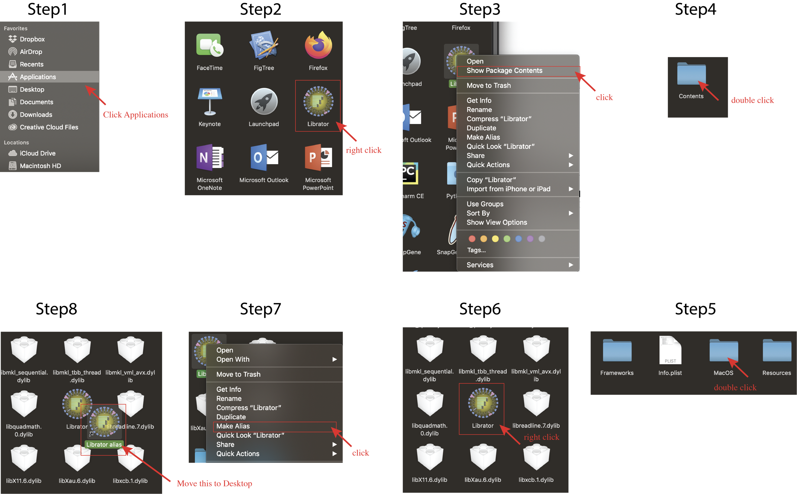

# User interface

### Main Tab (printable)

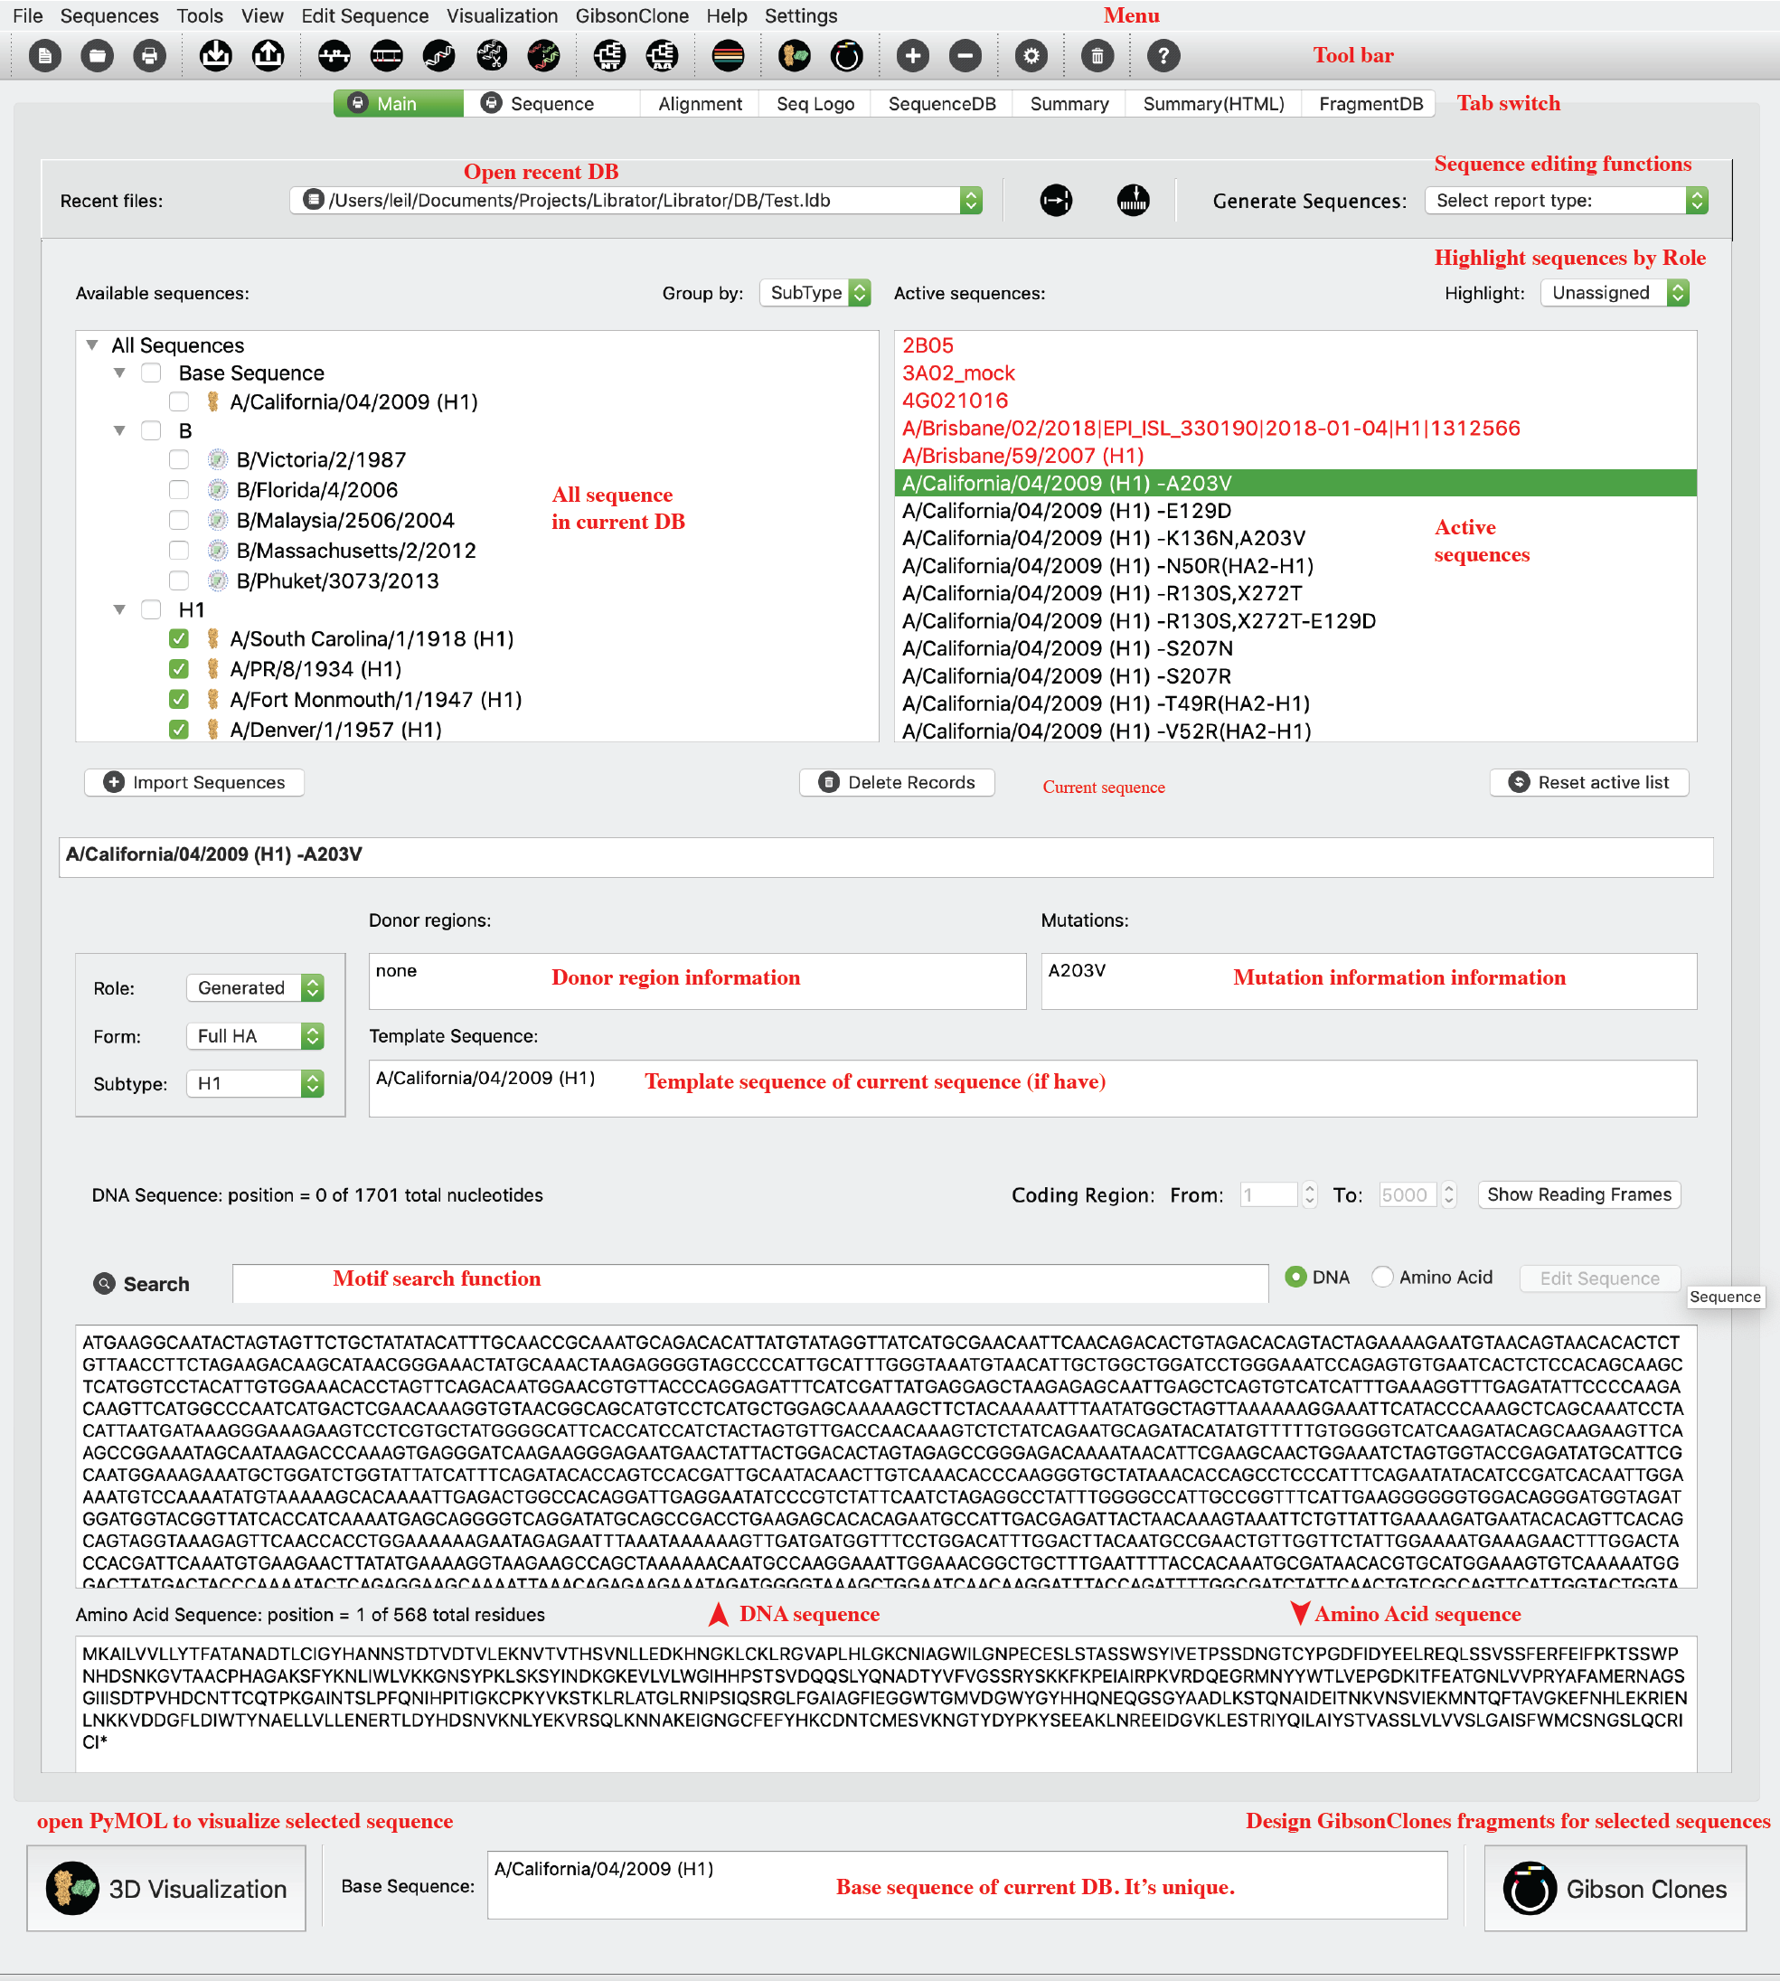

### Sequence Tab (printable)

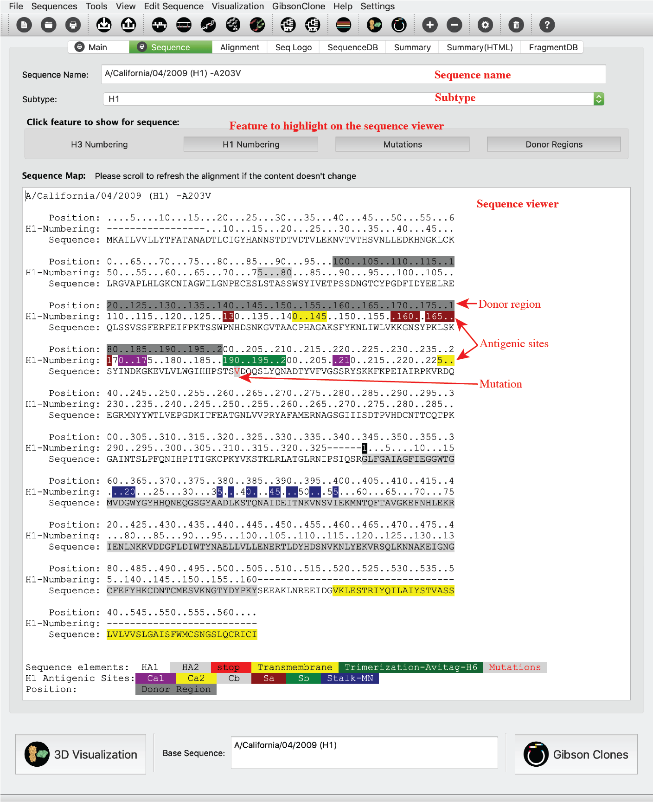

### Alignment Tab (HTML)

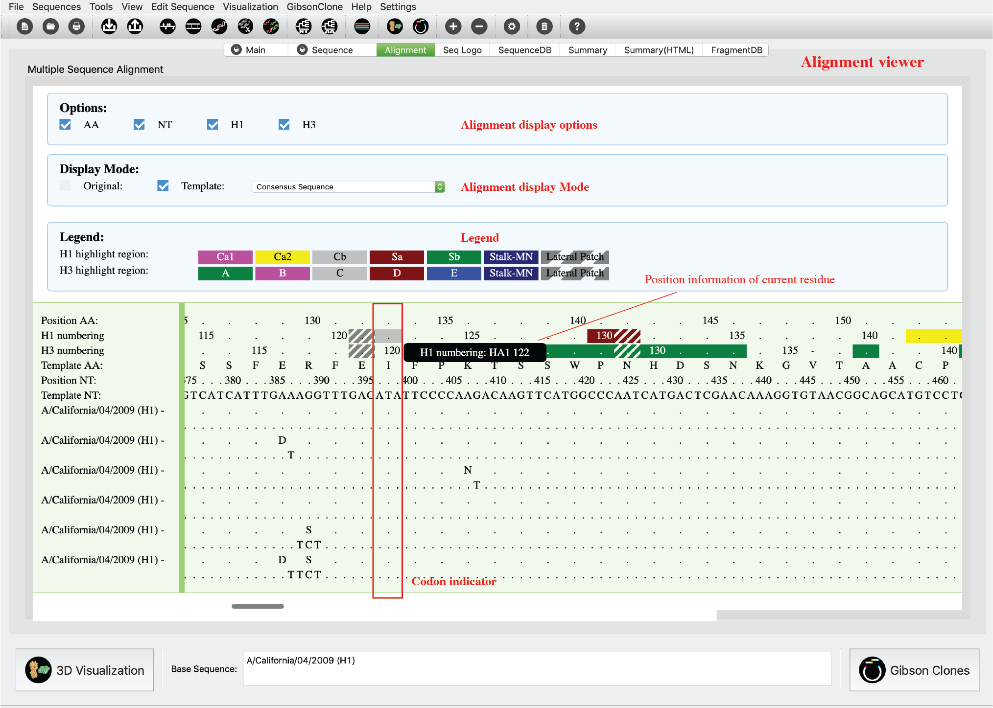

### Sequence DB Tab

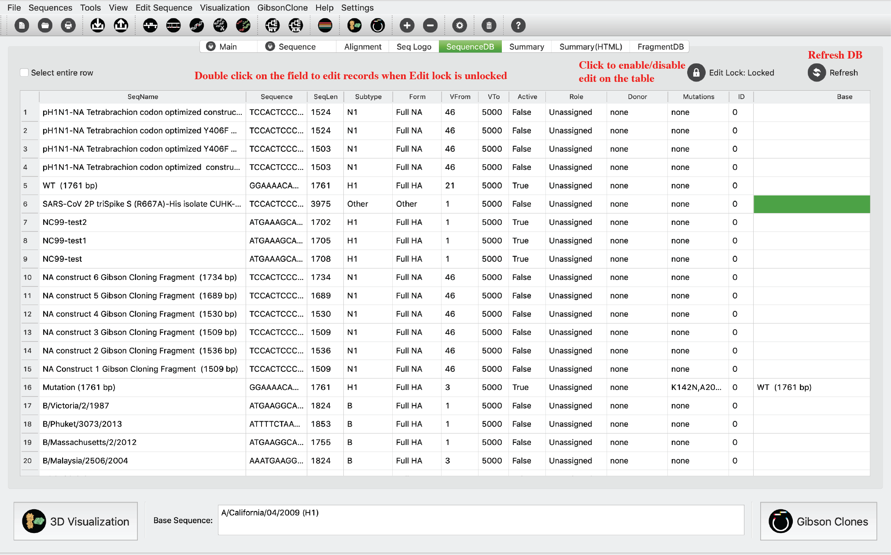

### Sequence Logo Tab

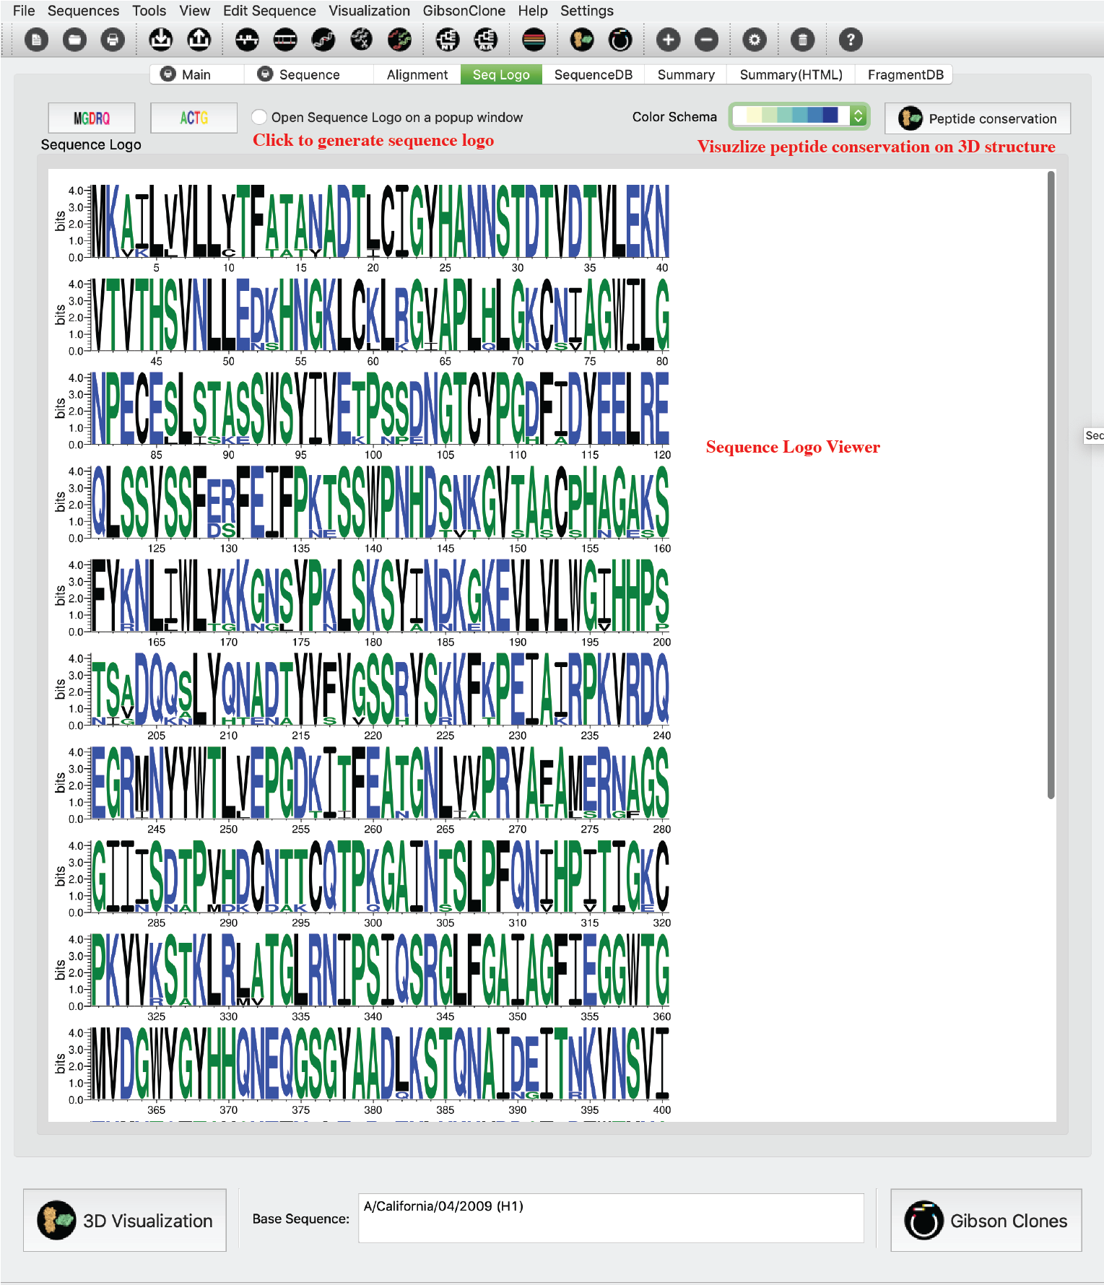

### Summary Tab

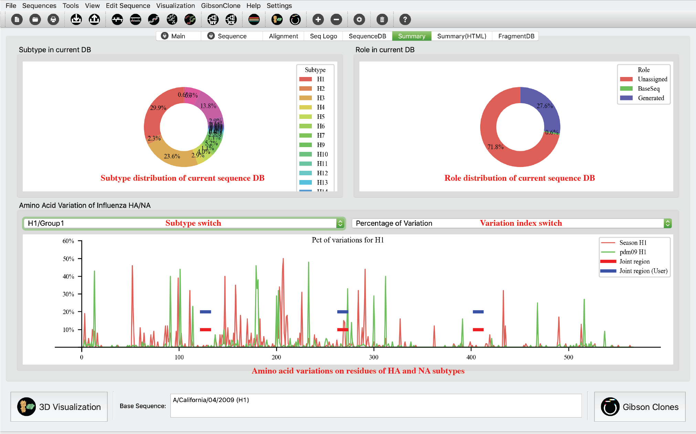

### Summary Tab (HTML)

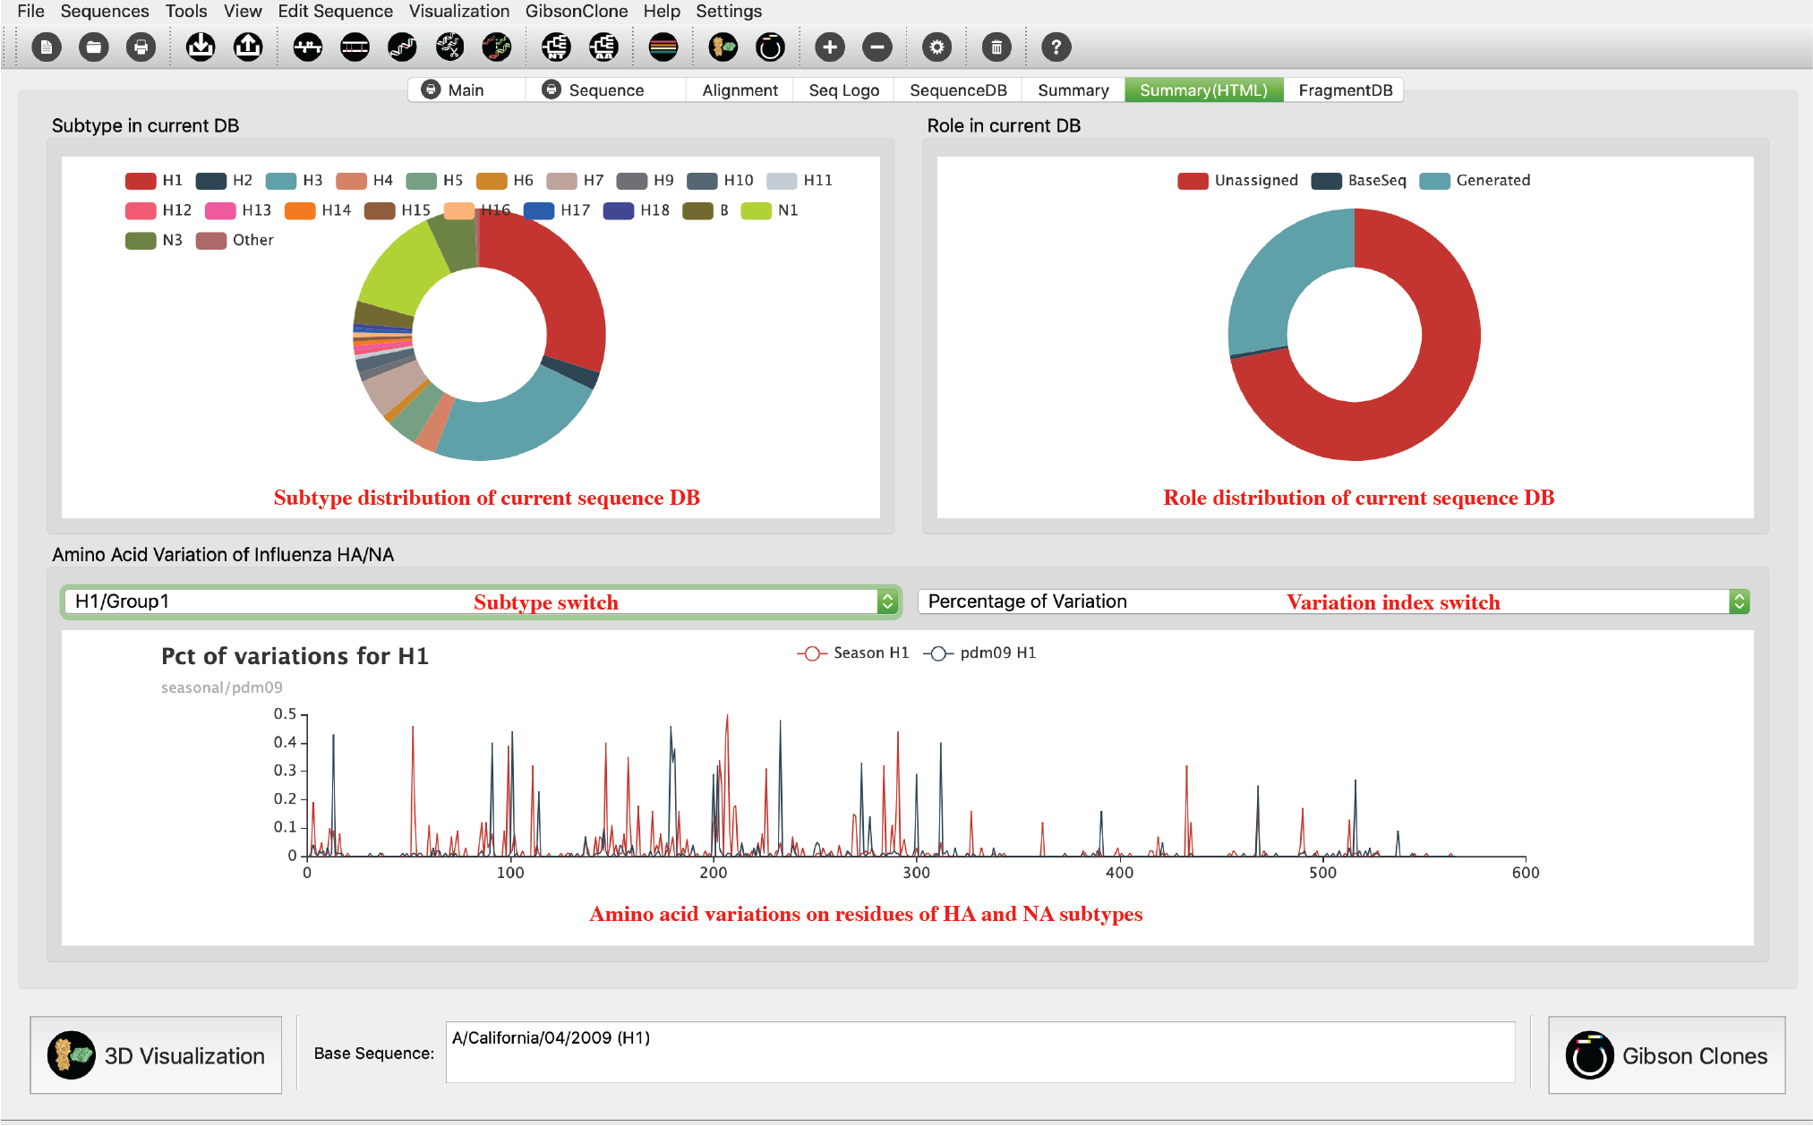

### Fragment DB Tab

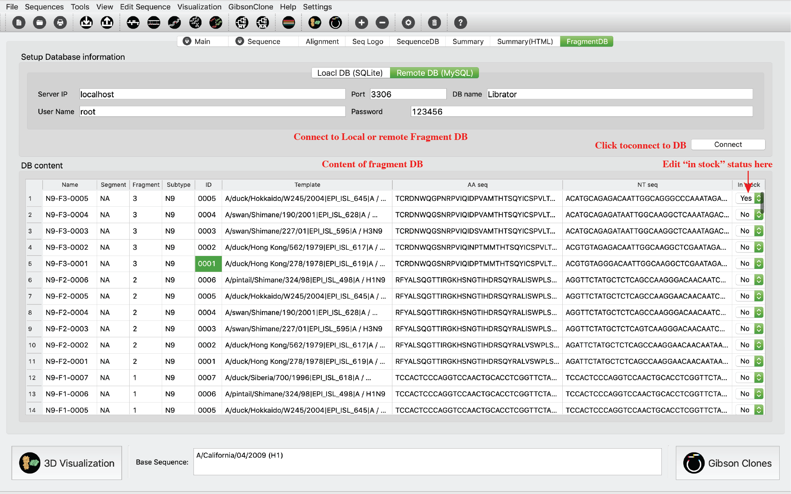

# Functions - basic functions:

### Path setting

Users can set paths for all required tools and databases.

Click *Setting-> Preferences* in menu or click  in *Tool bar*.

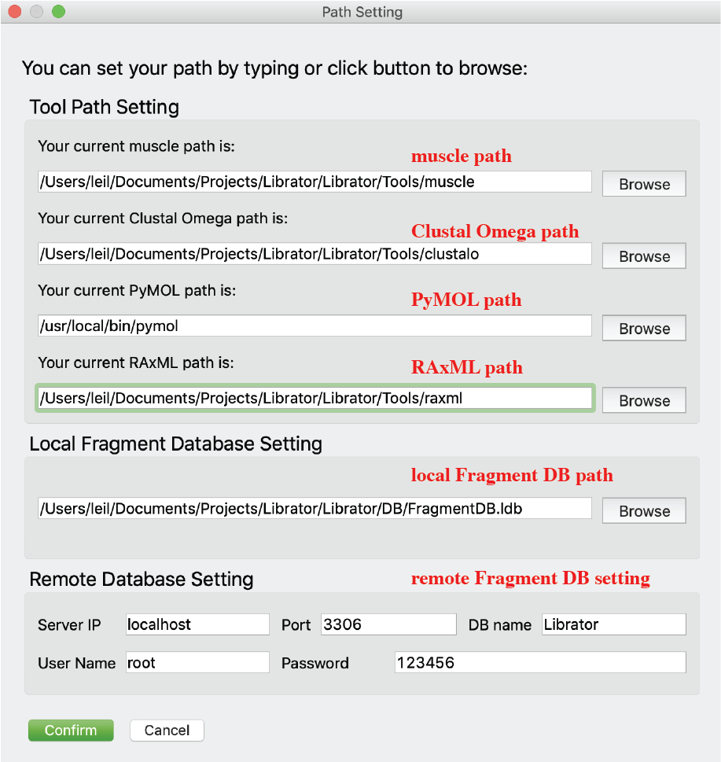

You can type path or click Browse button to choose the correct path.

### Create new sequence database

Users can create new sequence database.

Click *File-> New* in menu or click  in *Tool bar*.

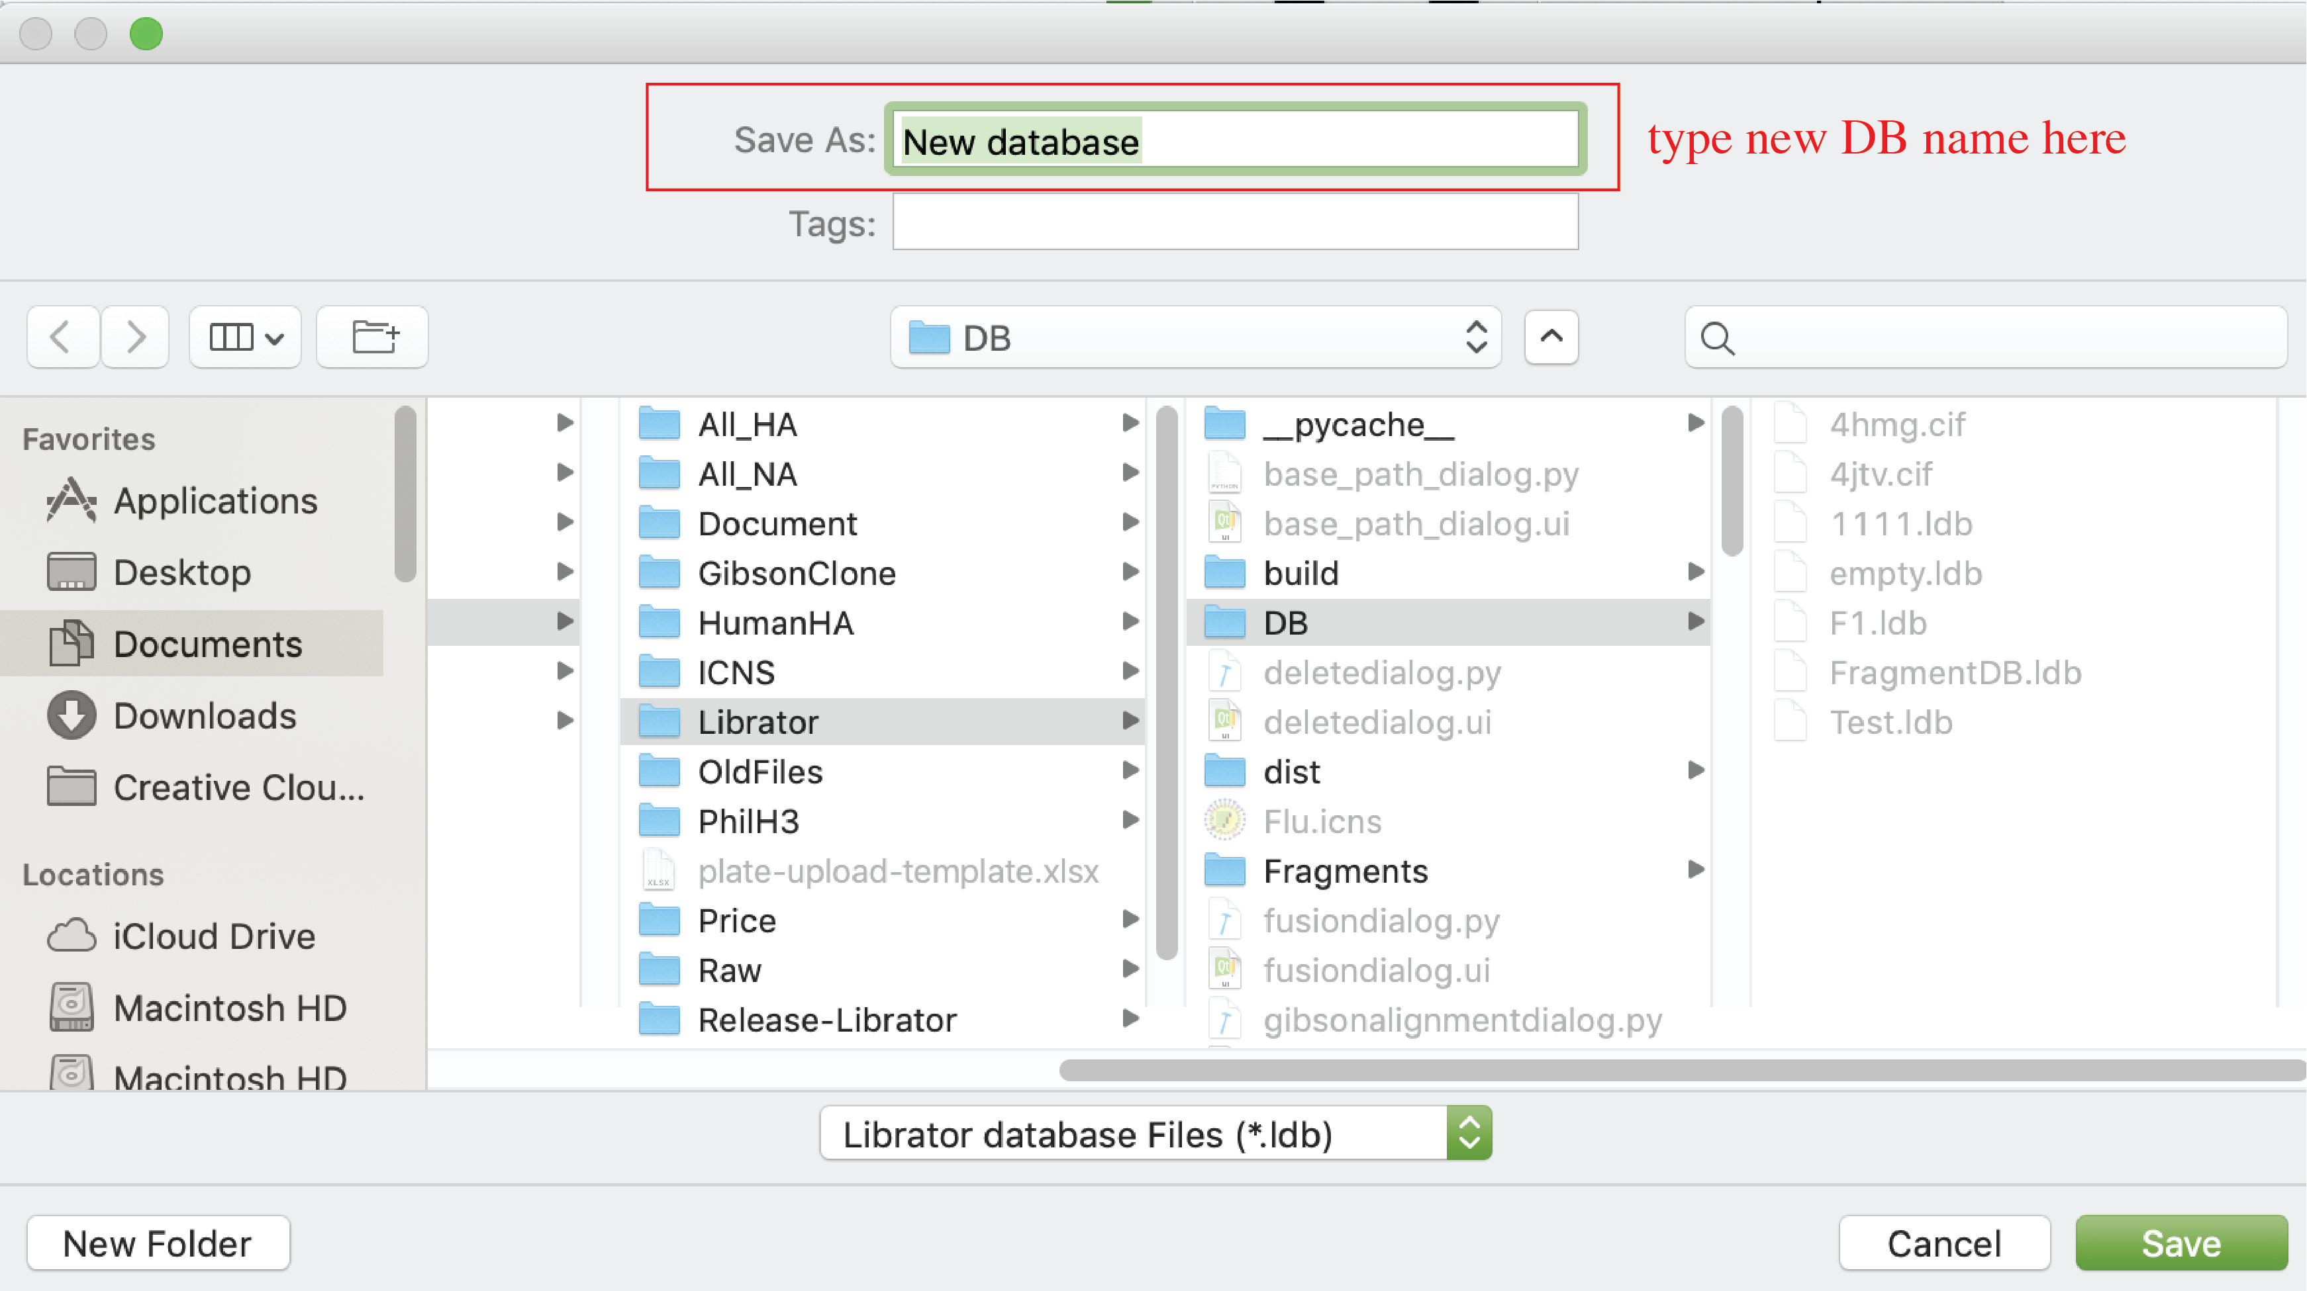

### Open existing sequence database

Users can create new sequence database.

Click *File-> Open* in menu or click  in *Tool bar*.

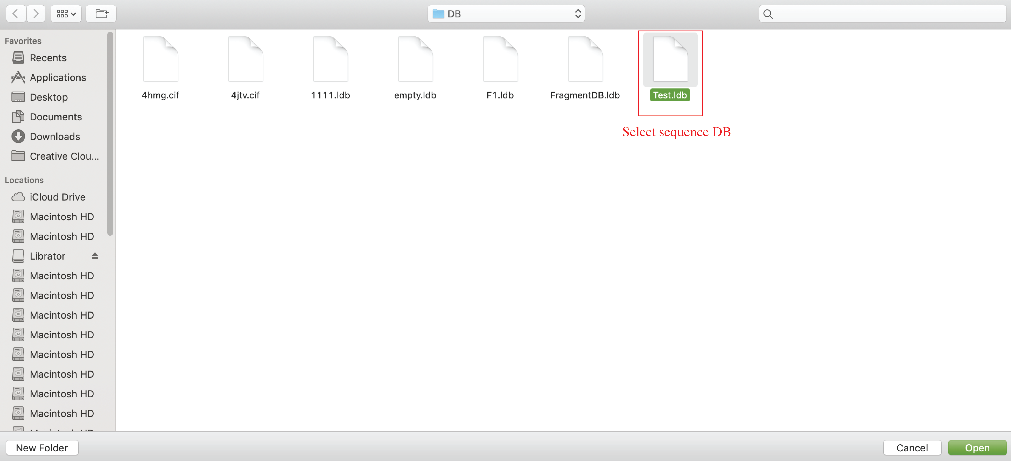

### Import sequences

After load an existing sequence database, users can import sequence into current database. The input files should be in FASTA format. Please also try to make your sequence name concise and easy to recognize. Try not to include space in your sequence name.

Click *Sequences-> Import* in menu or click in *Tool bar* or click “import sequences” button in Main tab.

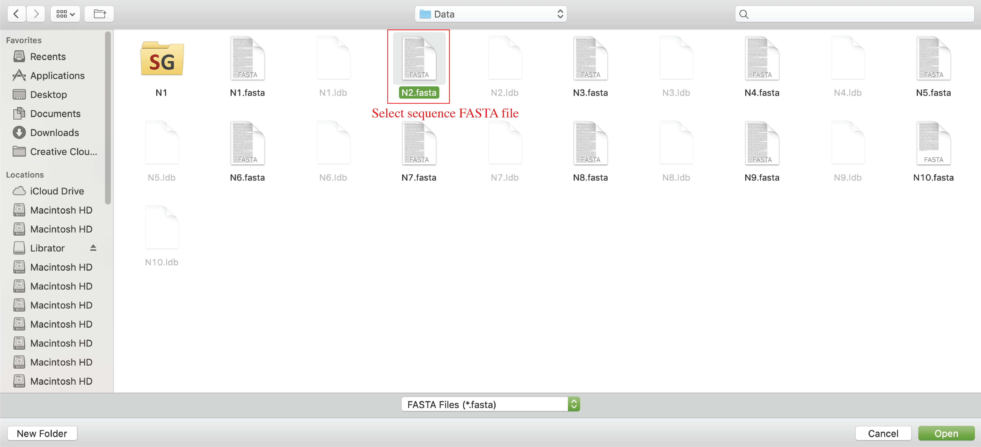

### Export sequences

After load an existing sequence database, users can import sequence into current database. Selected sequences will be exported to a FASTA file.

Click *Sequences-> Export* in menu or click  in *Tool bar*.

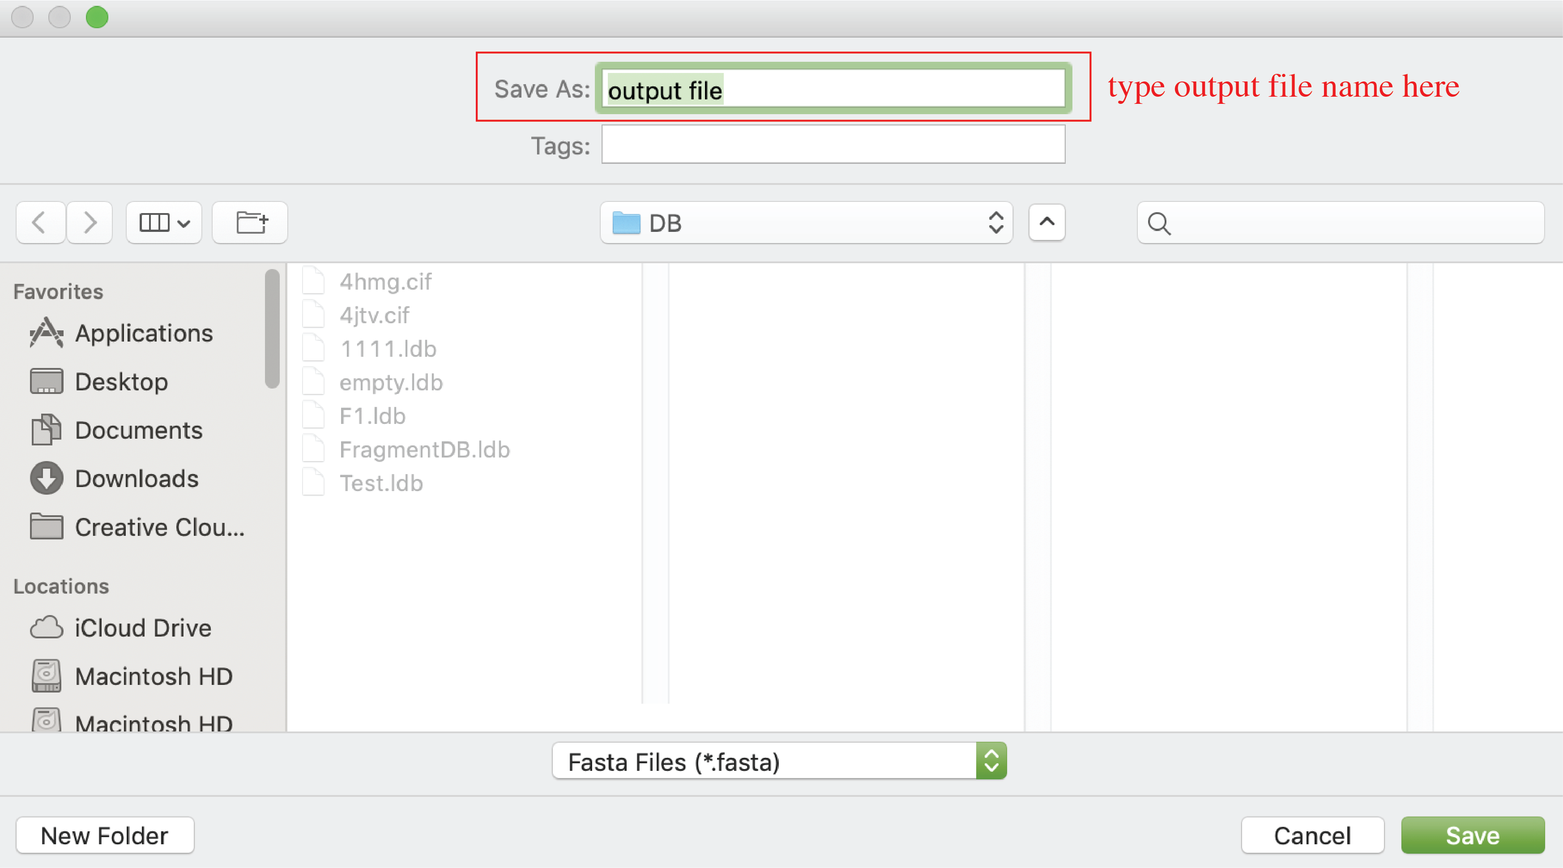

# Functions - advanced functions:

### Edit sequence information (on Main tab)

Users are allowed to edit information (**sequence name**, **Role**, **Form**, **Subtype**, **NT sequence**, **reading frame**, **donor regions**) of selected sequences on main tab.

1. For **Sequence name**, users can click sequence name text input to edit it.

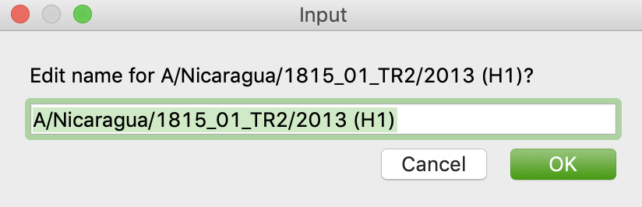

1. For **Role**, **Form**, and **Subtype**, users can edit by the left panel. Users can select multiple sequences in active sequence panel to do bulk update.

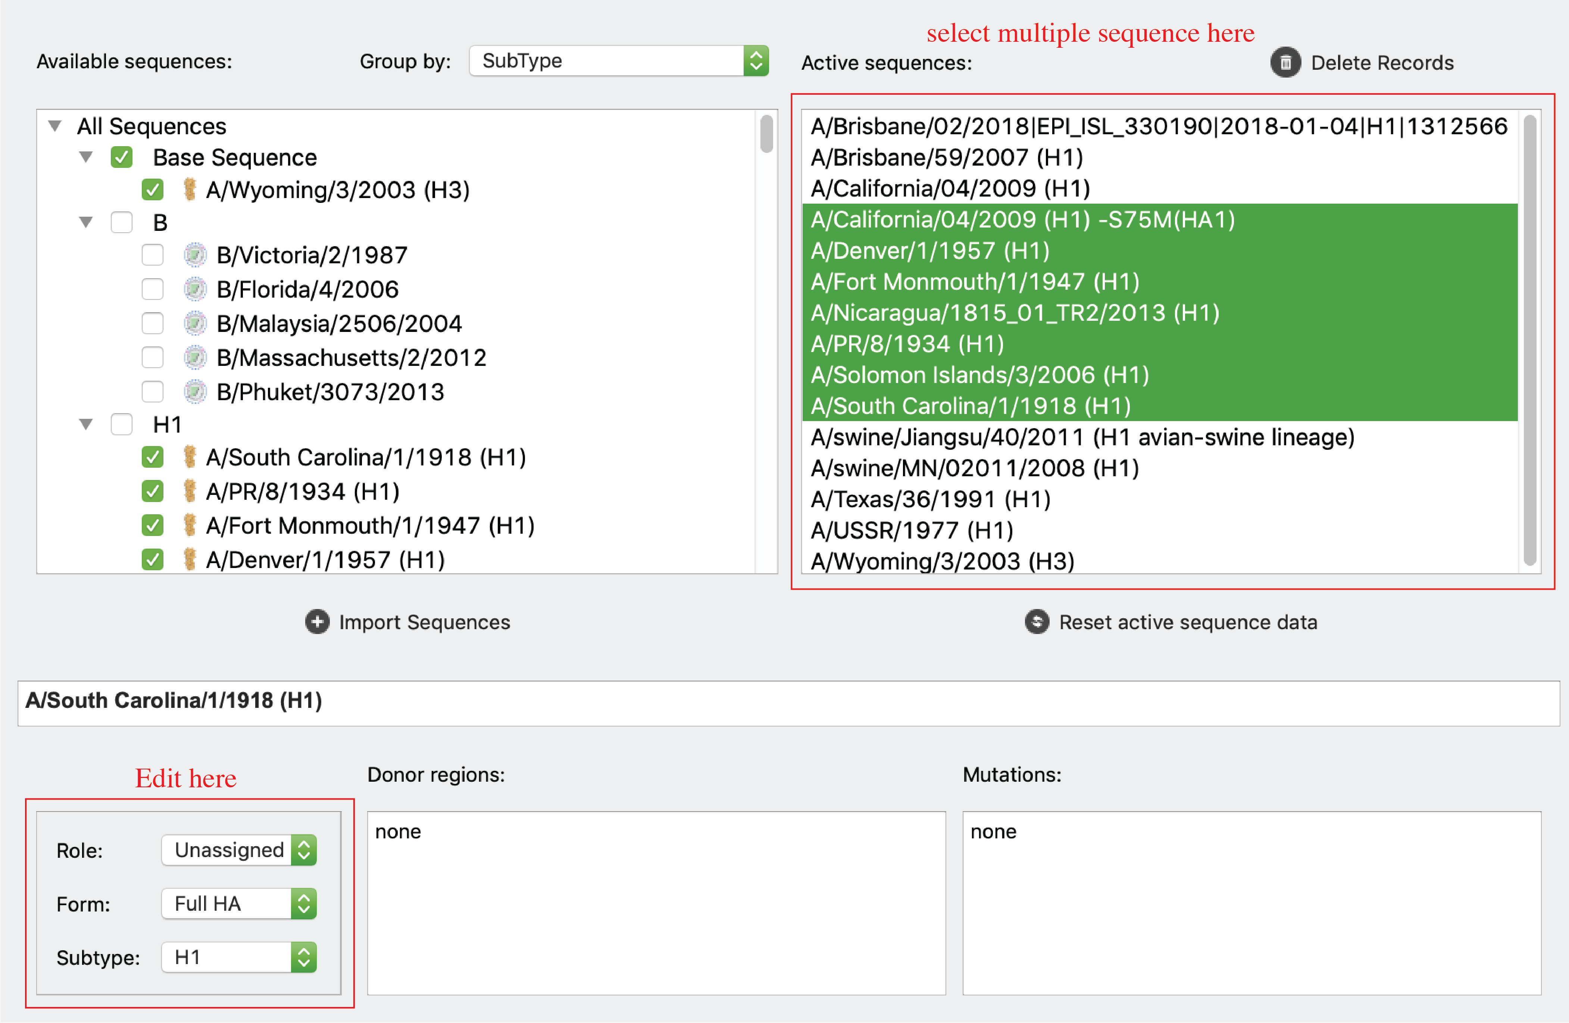

1. For **reading frame** start and end, users can use the “Coding region” inputs. When users change coding region setting, the amino acid sequences will be updated accordingly.
2. For **NT sequences**, users can click “edit sequence” button to edit sequences in the following pop-up window.

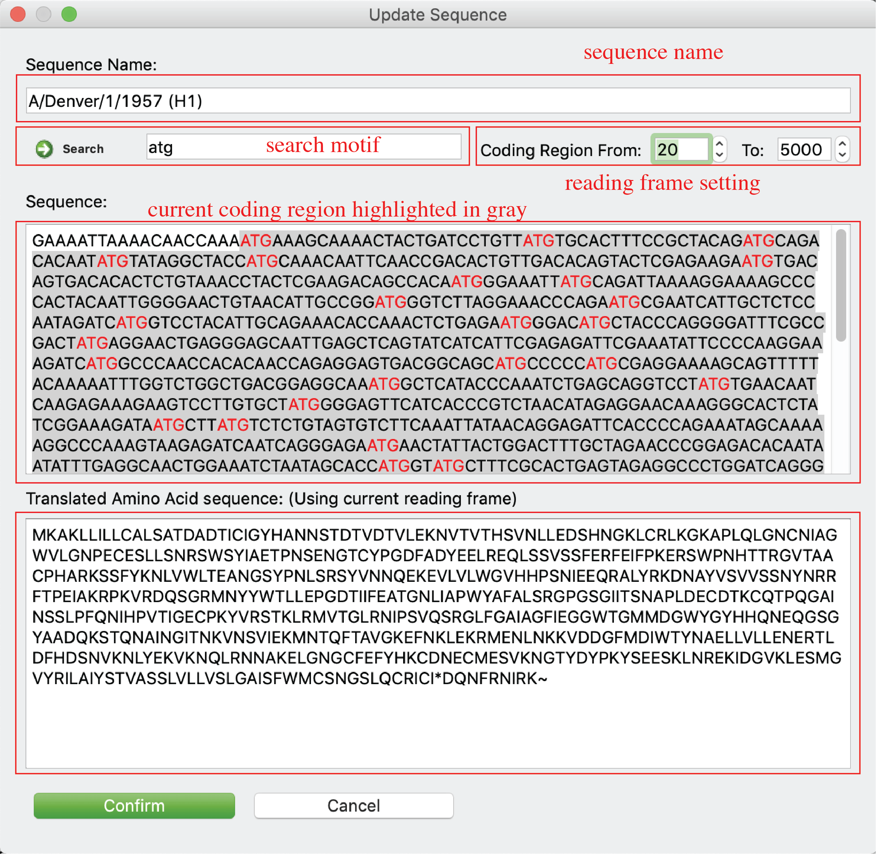

Note: coding region and NT sequence editing is disabled for sequences with mutation information.

1. For **donor regions** information, users can click “Donor region” input to update information.

### HA numbering system

Users are allowed to access H1/H3 numbering of selected sequence. Two ways:

1. Please select your sequence on active sequence panel and then click *Tools-> HA Numbering* in menu, or click  on *Tool bar*, or just click “Sequence” tab.

Please see “Sequence” Tab for interface and details.

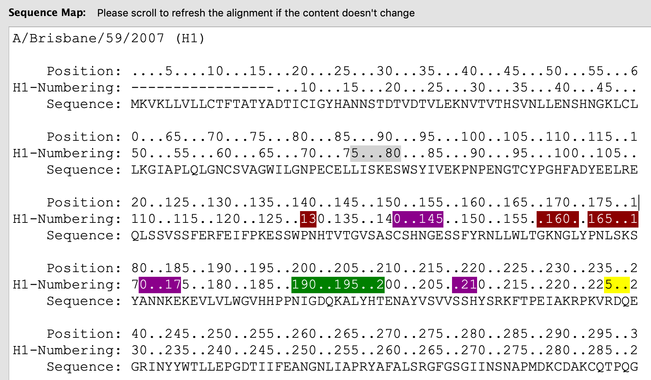

1. Please select your sequence on active sequence panel and then click “Alignment” tab or  on the *Tool bar*.

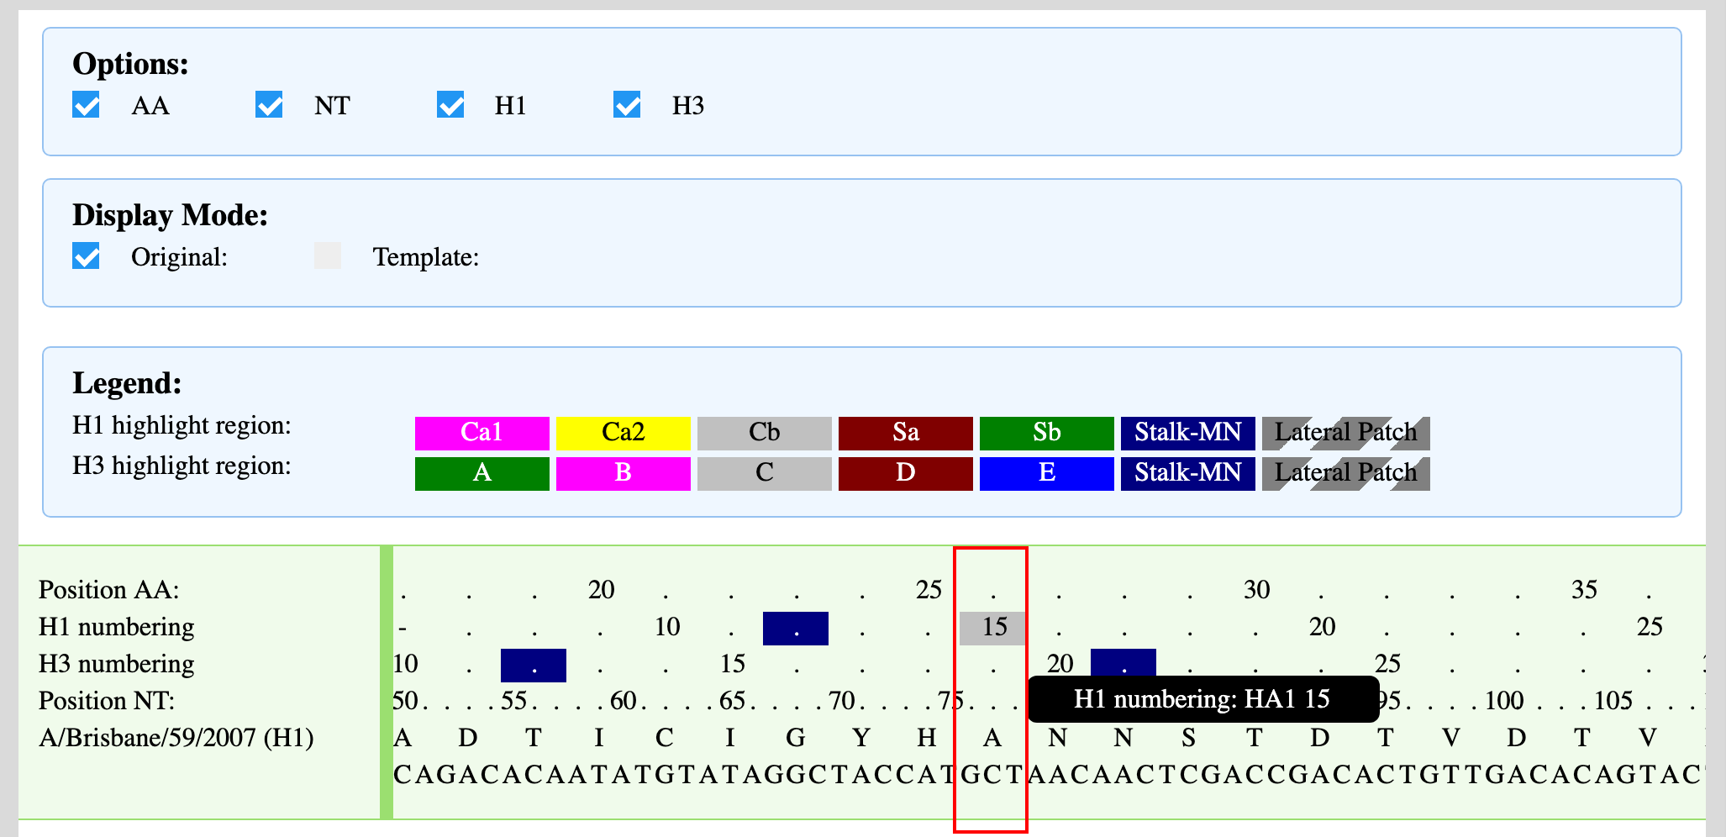

### Identify mutations

Users are allowed to identify mutations between any two sequences. If you have a template sequence and a mutated sequence (e.g. escape mutants) and want to quickly know the mutated residues, you can use this function to identify all mutations and annotate mutation information on your mutated sequence.

Click *Tools->Identify Mutation* in menu or just click 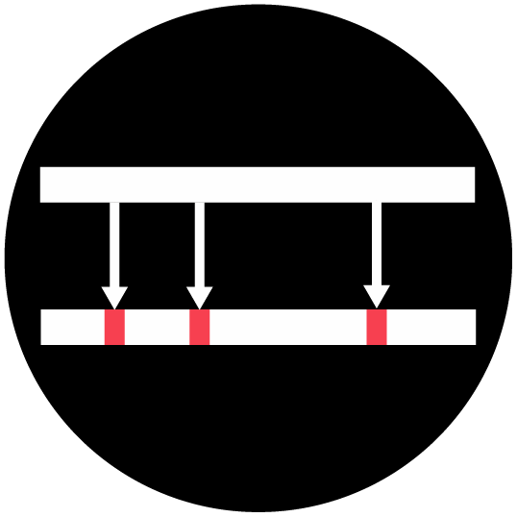 on *Tool bar* to open the function window. Then select one sequence as template, determine the mutated sequence as target sequence. Then the alignment will be displayed in the HTML viewer and all mutations will be listed in the bottom text box. Users can save mutation/template information to the target sequence by clicking “Confirm” button.

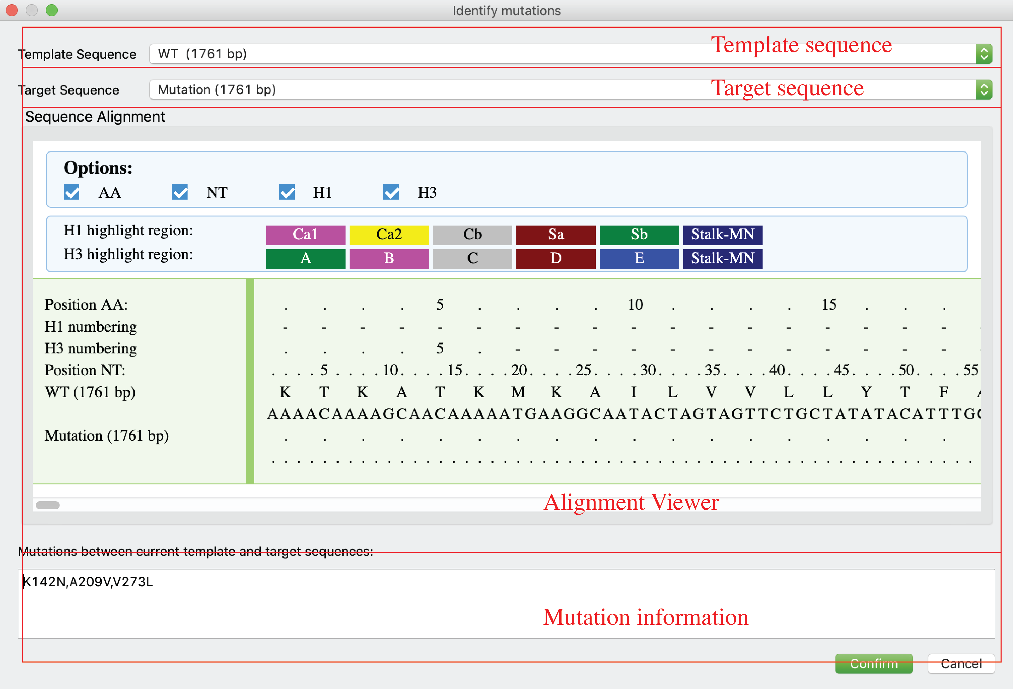

### Multiple sequence alignment

Users can align multiple sequences together and check the results in a graphical viewer.

Click *Tools-> Multiple Alignment (HTML)* in menu or just click  on *Tool bar* for an alignment viewer in a popup window or click Alignment (HTML) tab for an integrated and alignment viewer. There are two display modes: original sequence mode (panel A) and template mode (panel B). In template mode, users can choose any sequence (including consensus sequence) as template to only highlight sequence differences.



### Generate phylogenetic tree (ML tree)

Users are allowed to generate phylogenetic tree (Maximum Likelihood tree) for selected sequences. Nucleotide and Amino Acid trees are available.

For Nucleotide tree:

Click *Tools-> Generate Maximum Likelihood Tree (nucleotide)* in menu or just click  on *Tool bar*.

For Amino acid tree:

Click *Tools-> Generate Maximum Likelihood Tree (Amino Acid)* in menu or just click  on *Tool bar*.

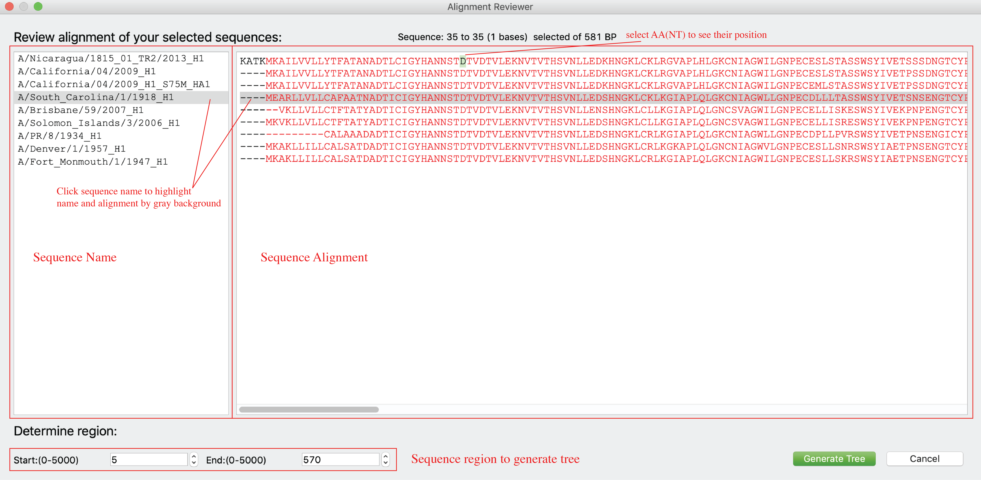

Users are allowed to review alignments before building the tree. Users can determine a specific region of the alignment to avoid interference from sporadic insertion/deletion (as shown in the figure, selected regions were highlighted by red).

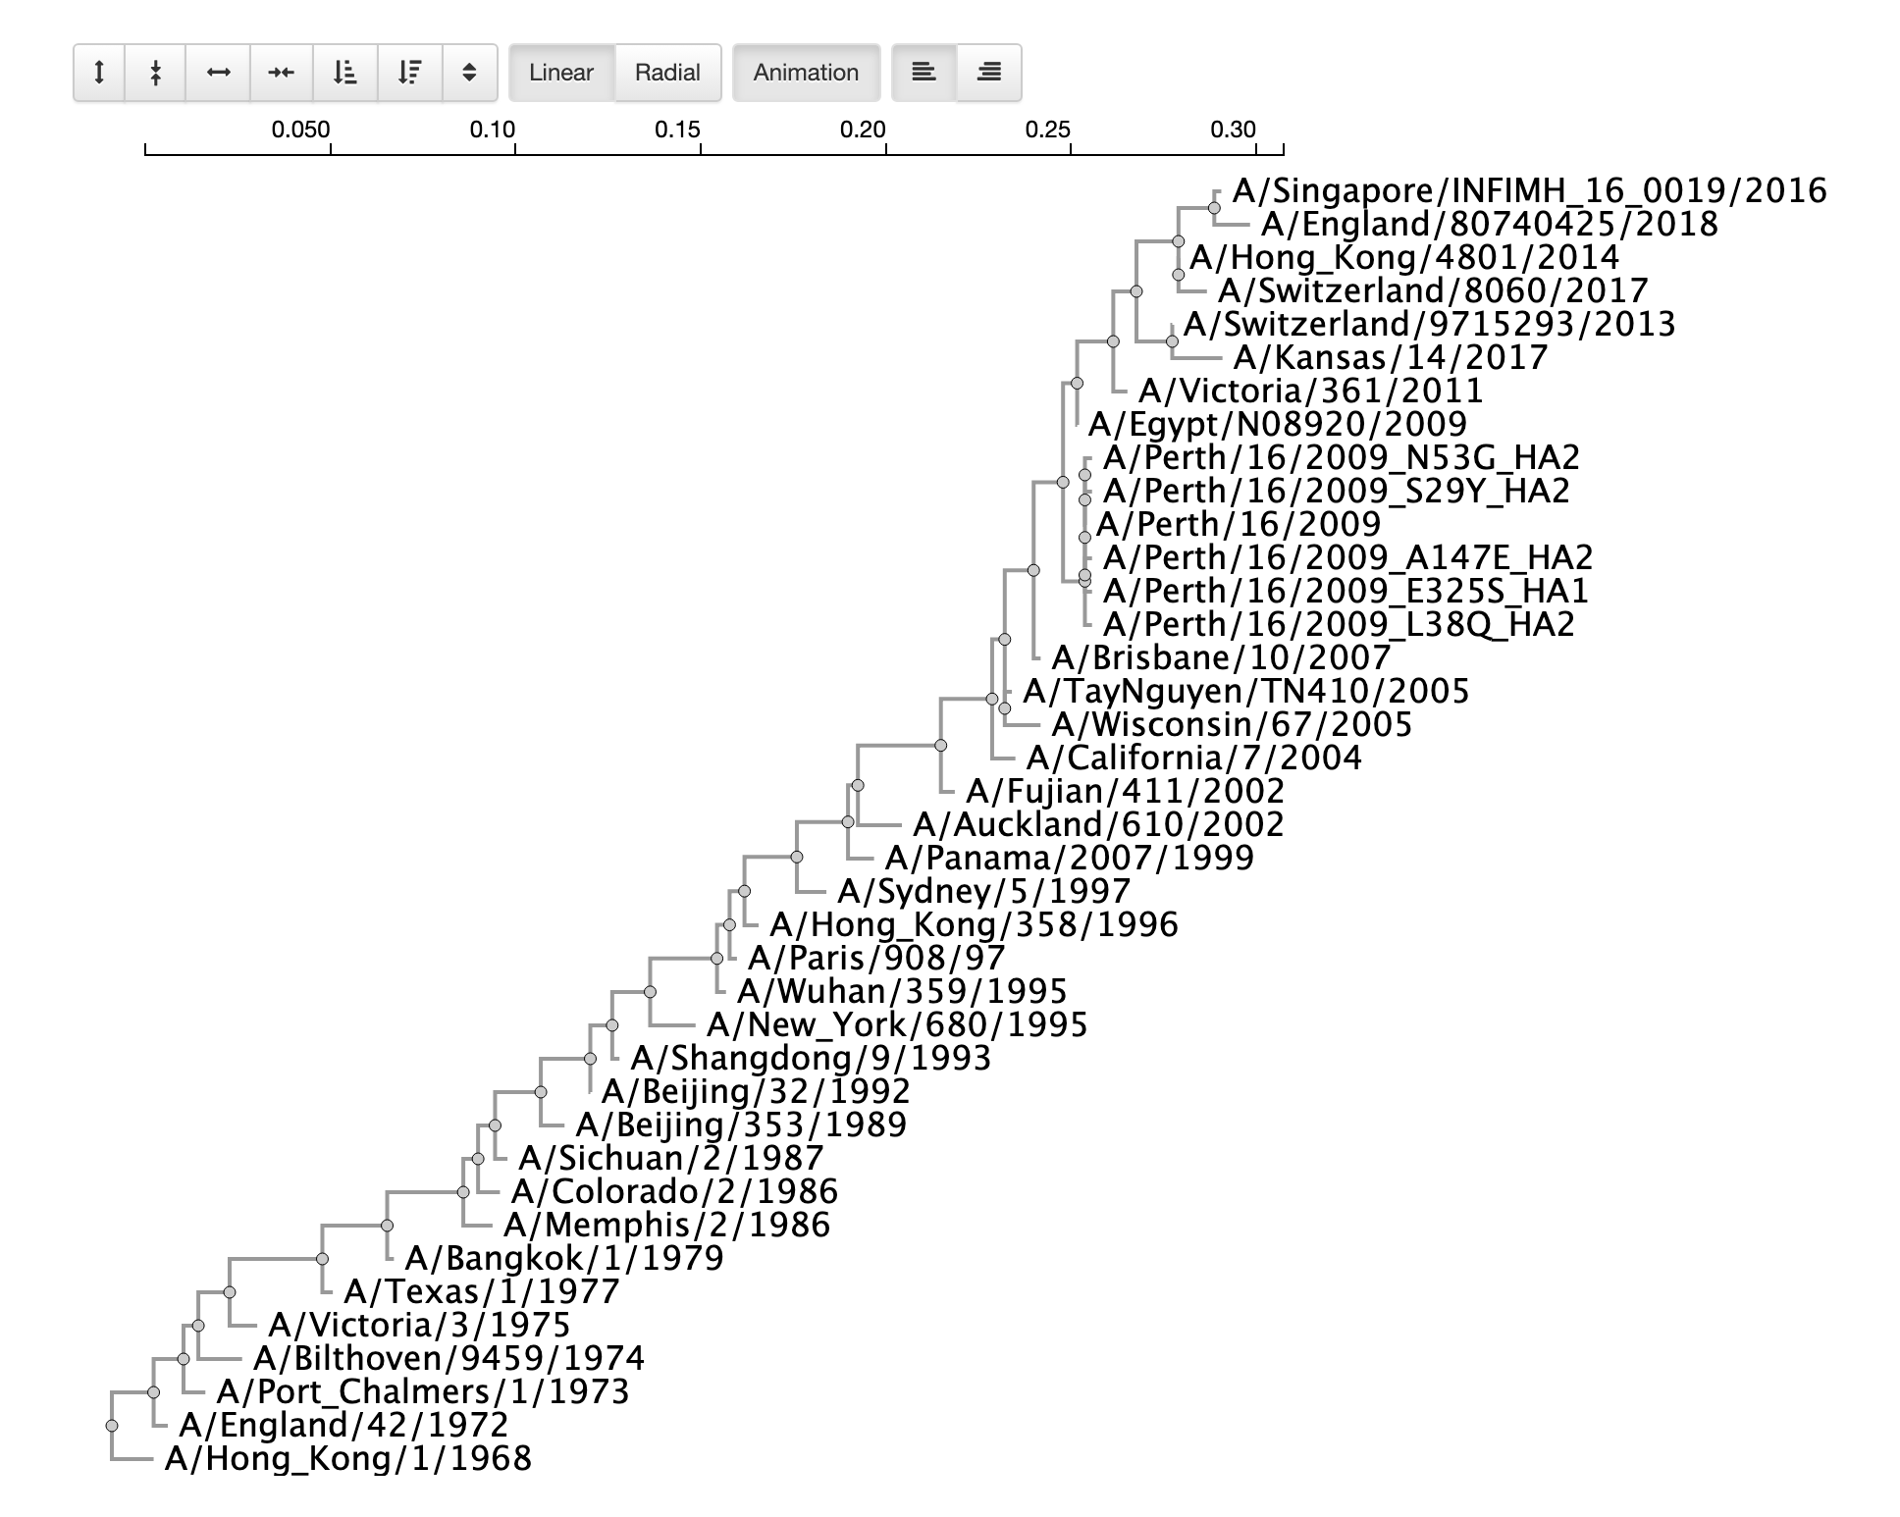

### Generate sequence Logo (peptide/nucleotide conservation)

Users can generate sequence logo for multiple selected sequences.

Users should select multiple sequence in main page, then click “Seq logo” tab. On “Seq logo” tab, users can click *Peptide logo* or *Nucleotide logo* to generate sequences logos (Panel A). Users also can check the checkbox called “open Sequence logo on a popup window” to view the sequence logo on a popup window and then can be saved as an EPS file (vector graph) for further use.

Users also can click the button on the right top corner to visualize peptide conservations for selected sequences on a 3D structure using PyMOL (panel B).

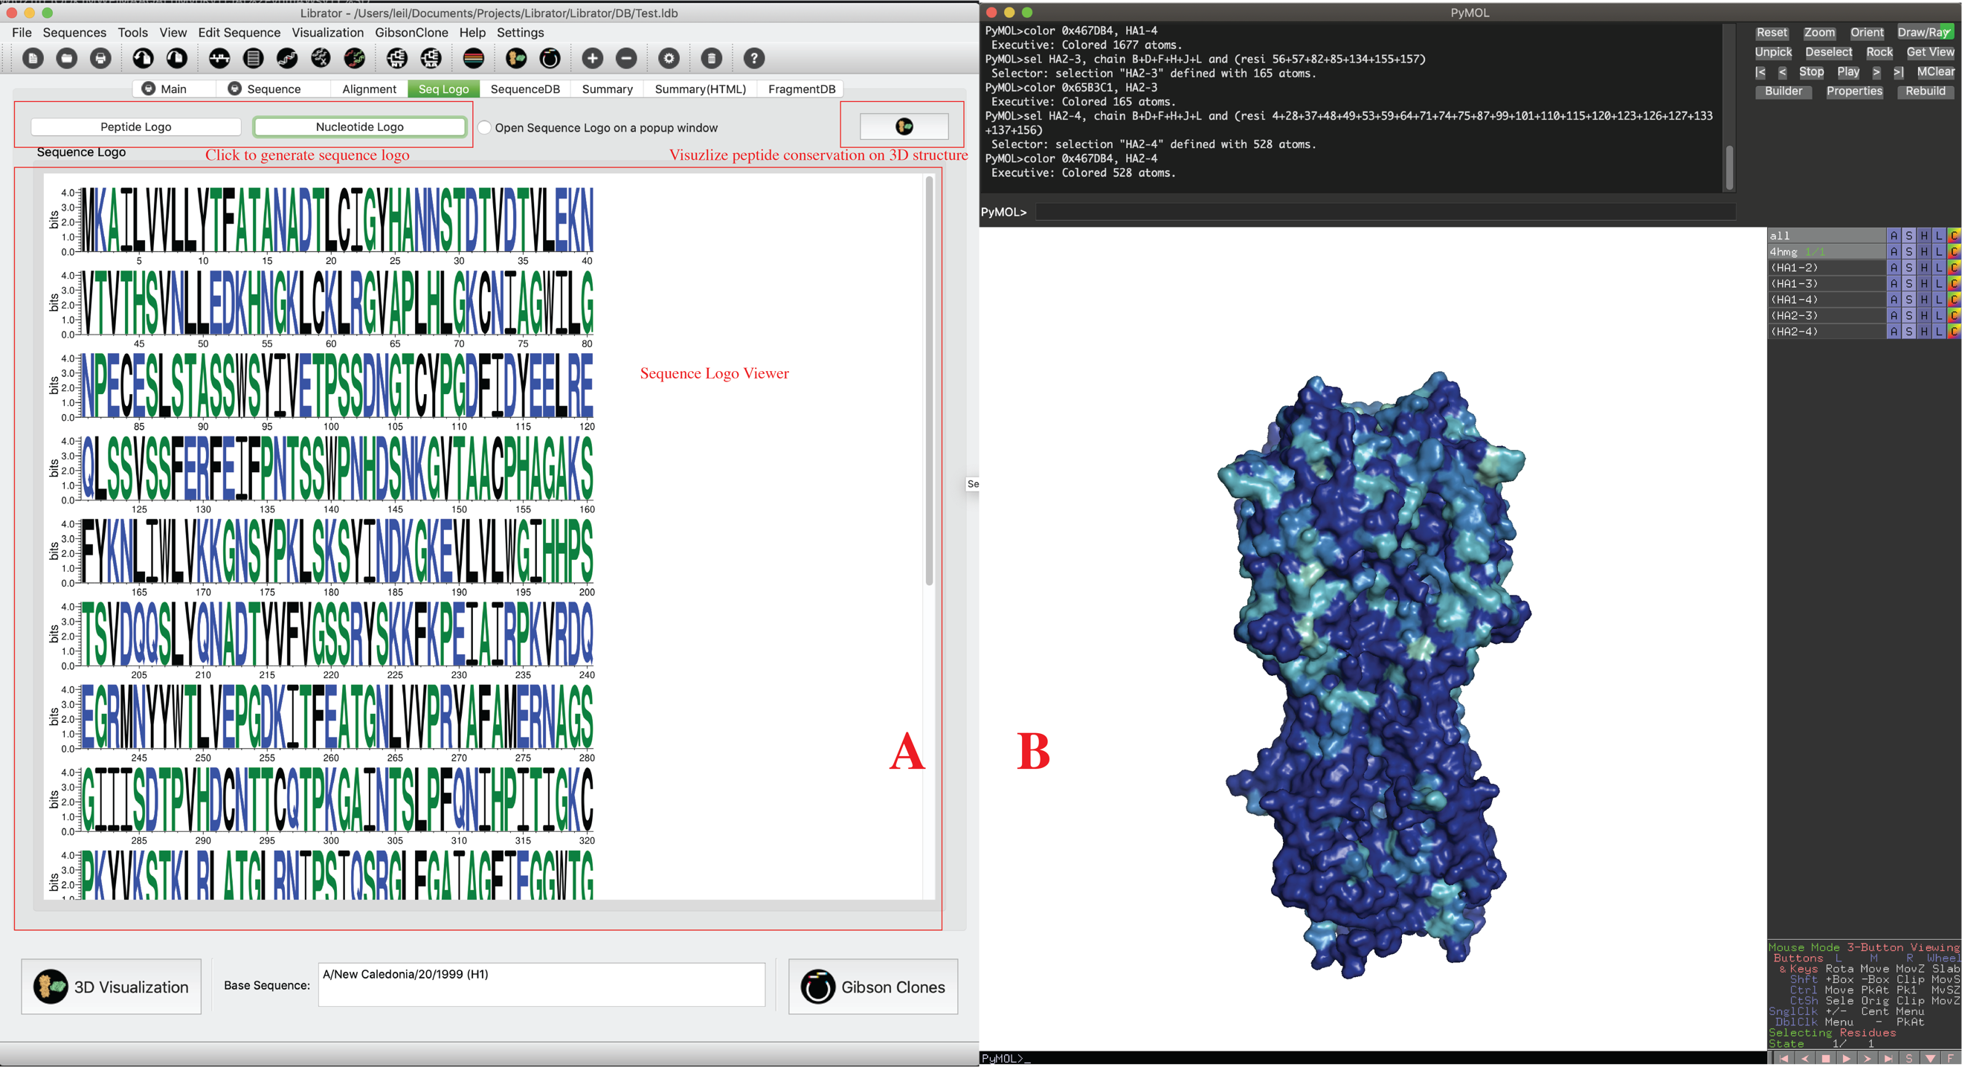

### Mutate sequence

Users can generated new sequences with mutations based on any existing sequence.

Click *Edit Sequence-> Mutation* in menu or just click in *Tool bar*.

As shown below, users can generate mutations on a template sequence using either original position (count from first amino acid, panel A) or H1/H3 numbering (H1 numbering for group1 virus and H3 numbering for group2 virus, panel B). H1/H3 numbering function is only enabled for HA sequences of FLU A.

Users are allowed to input multiple mutations at the same time, and then to decide from two options: 1) generate one sequence with all mutations; 2) generate multiple sequences, each of them with a single mutation.

After the mutated sequence was generated, users can visualize the 3D structure (only enabled for HA now) of generated HA protein (panel C).

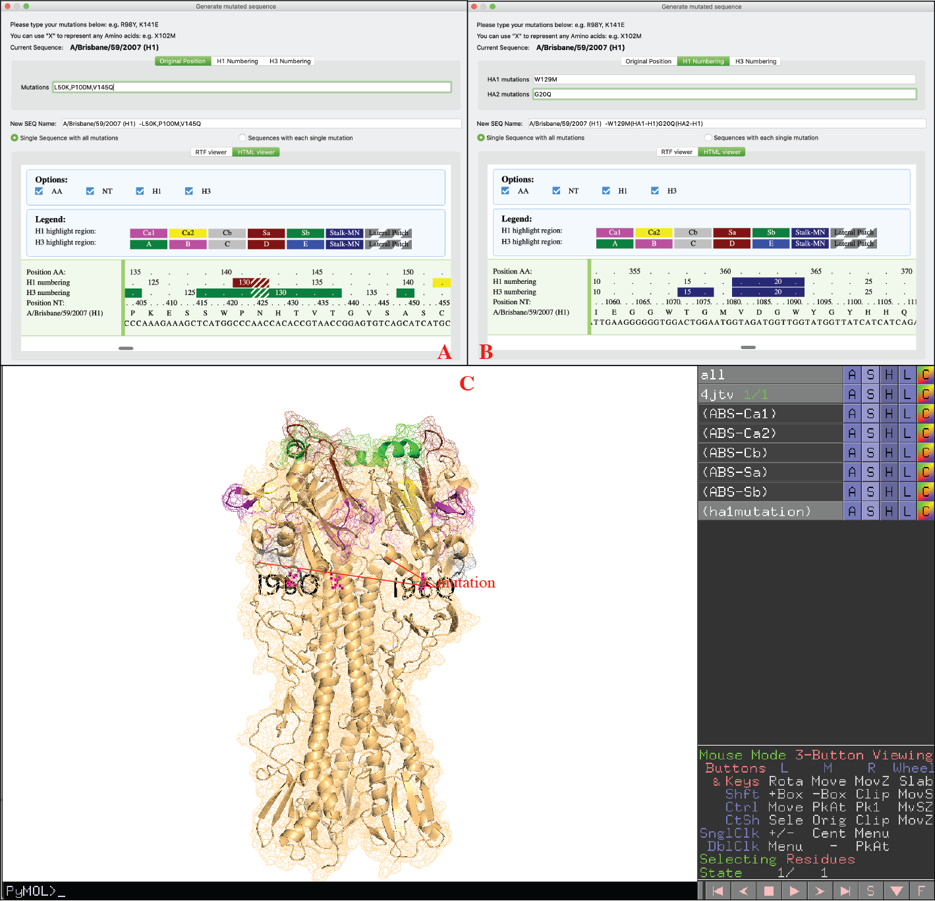

### Compare sequences and generate screening mutations

Users can compare sequences and generate consensus sequences (Base biased) or new sequences with screening mutations (Cocktail).

Click *Edit Sequence-> Editing* in menu or just click on *Tool bar*.

*Cocktail mode* **(A):**

Compare base sequence to another sequence, identify all mutations between two sequences on donor region of donor sequence (user can setup donor region on this interface), then generate new sequences with those mutations using base sequence as template. Users can choose to only generate sequences with single mutations or all combinations of mutations.

*Base biased mode* **(B)**:

Generate consensus sequences of base sequence and selected sequences. For each donor sequence, only their donor region will be considered (full sequence will be considered when donor region is none).

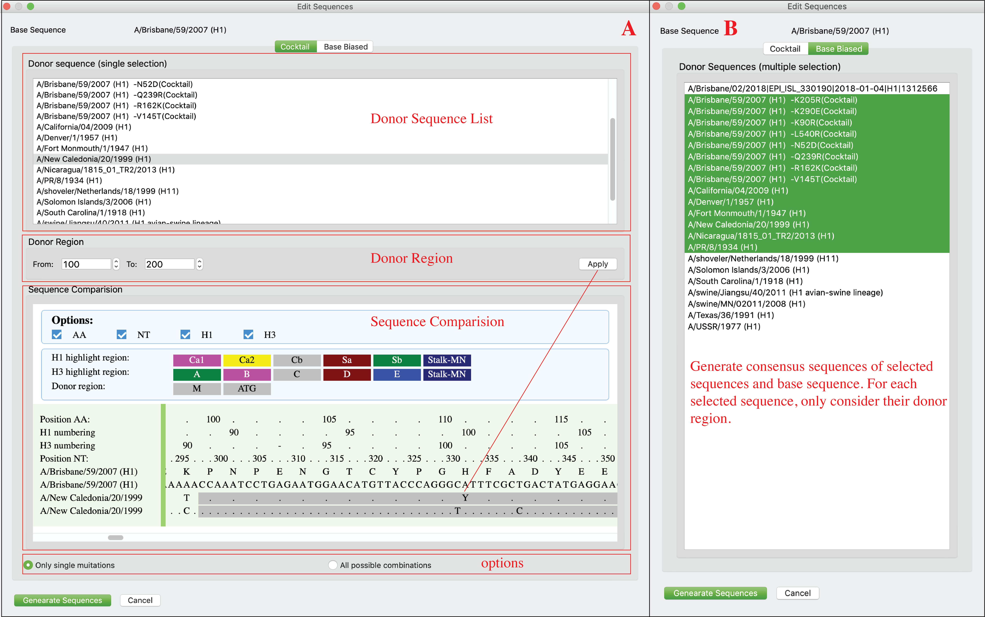

### Epitope transplant across different subtypes

Users can transplant epitopes/regions from sequences of different subtypes. This function could be helpful for designing chimeric HA protein.

Regions being removed from base sequence and that being inserted from donor sequence are not necessary to have same length.

Users can add multiple replacements on one sequence (click ‘Add’). Those replacements could be from different sequences. Users can review the replacement design in the bottom window. Users can double click replacement to delete it. Users also can click ‘Clear’ button to rest current design.

Click *Edit Sequence-> Fusion* in menu or just click 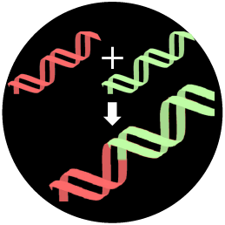 in *Tool bar*. This window has two layouts: high-resolution layout and low-resolution layout. Liberator will automatically choose the best fit based on current display resolution. Users also can click *Edit Sequence-> Fusion (high resolution)* or *Edit Sequence-> Fusion (low resolution)* to determine the layouts they prefer (As shown below).

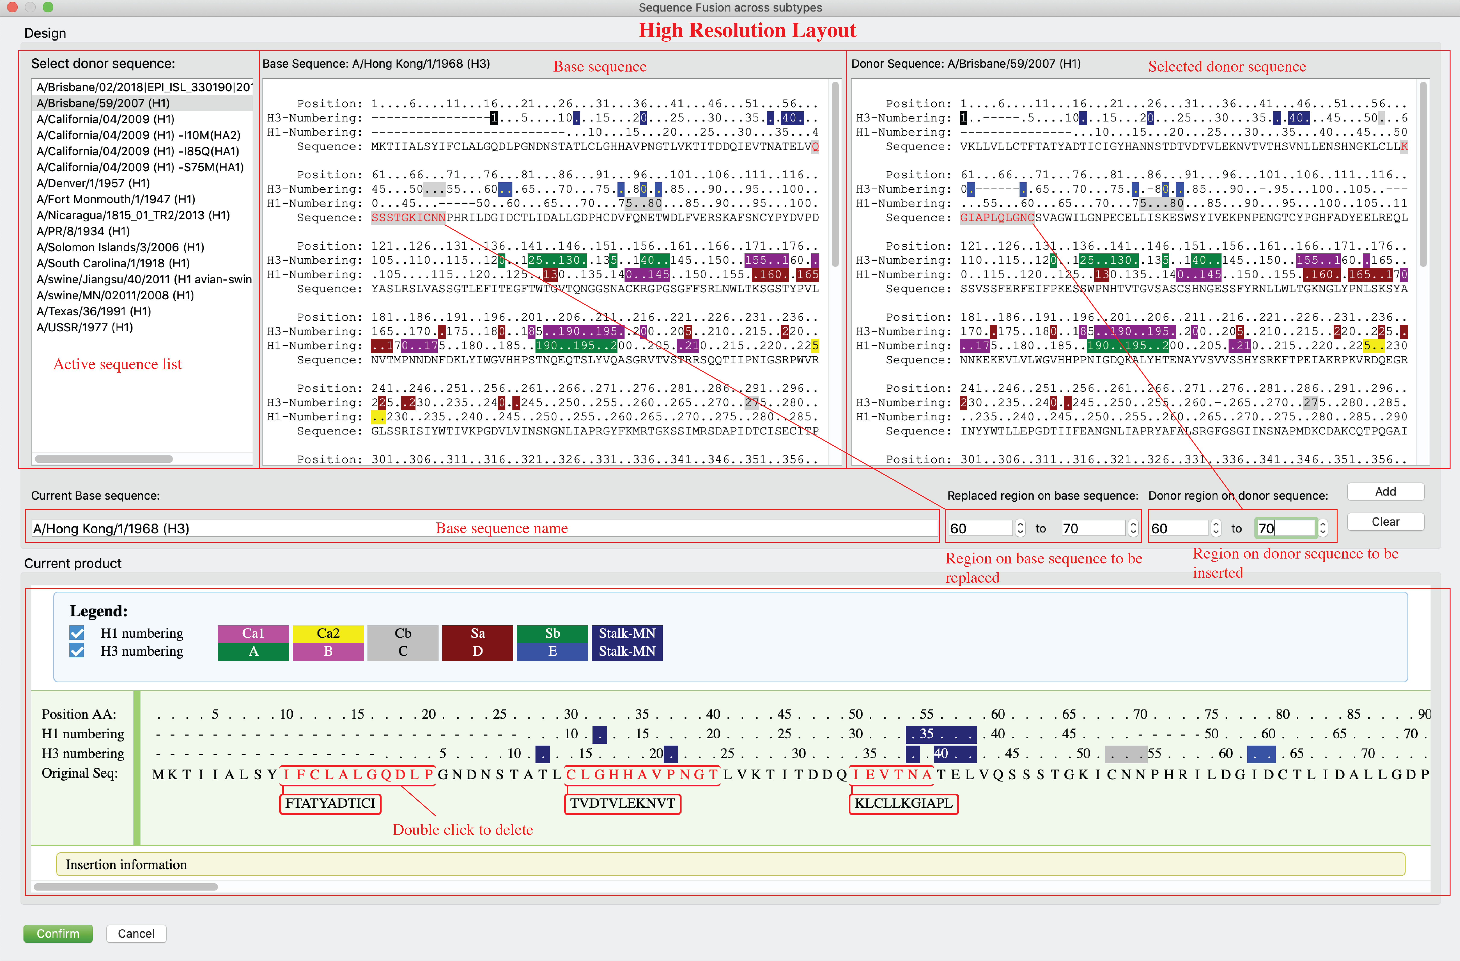

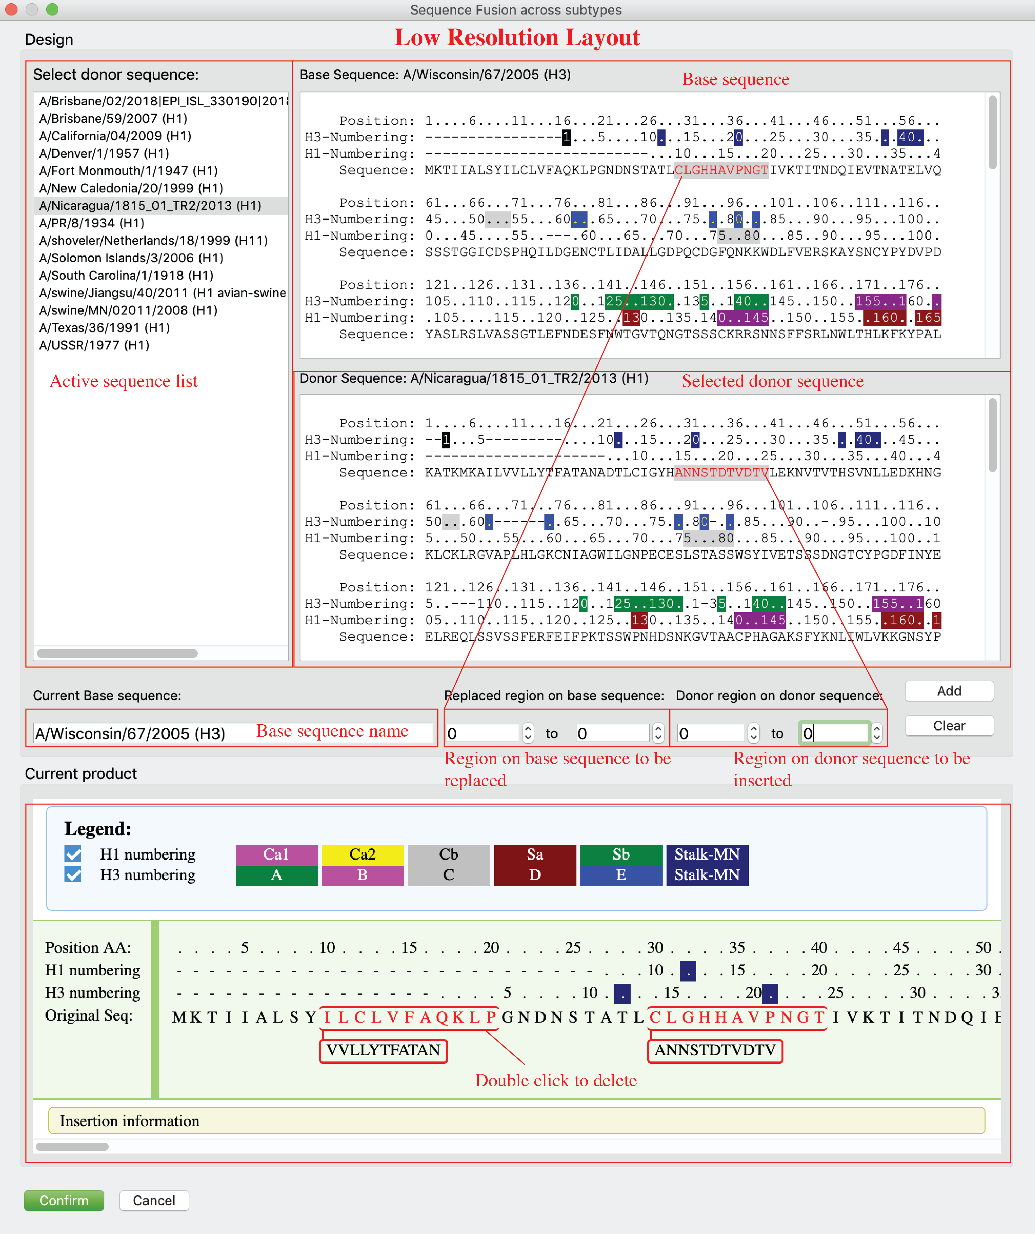

### 3D visualization via PyMOL

Users can see 3D structure of selected sequence via PyMOL (only for HA for now).

Please select any sequence in active panel and then click *Visualization-> PyMOL* in menu or 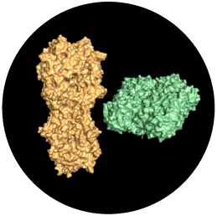 button on tool bar.

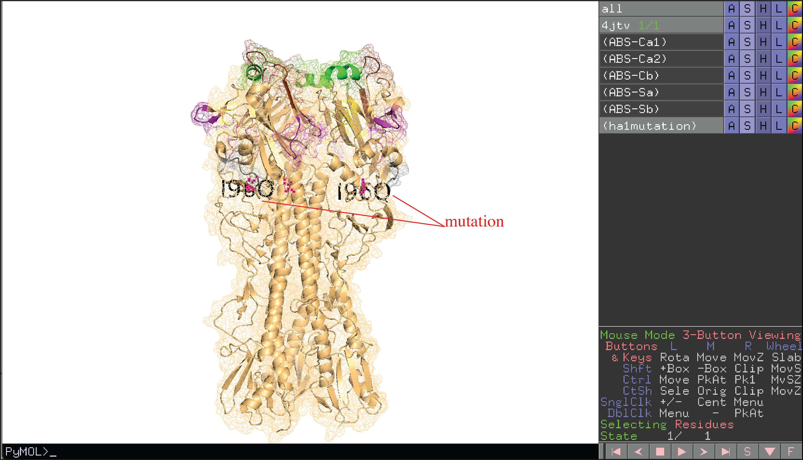

### Generate Standardized Gibson Clone fragments for HA/NA in batches

Users can generate standardized Gibson Clone Fragments for HA/NA sequences in batches. Those fragments are reusable due to they are following the same design.

Click *GibsonClone*-> *GibsonClone* in *menu* or just click  button on Main tab.

Note: *GibsonClone* only works for sequences within same subtype!

Users can select sequences, determine fragment DB, output path, and joint region plan (panel A), after click “Generate Fragments” button, a dialog will pop up for users to review and confirm (panel B). On panel B, users can review the generated Fragments (both amino acid sequences and nucleotide sequences). Joint region that connect fragment 1 and 4 to the vector not displayed for AA sequences but will be automatically added to NT sequences. ‘-’ in AA alignments indicate incomplete sequences or deletions and will be deleted in NT fragments. Users can click “confirm” button to generate fragments after they confirmed current fragments. After a few second, a notice will be popped up with summarized results (panel C).

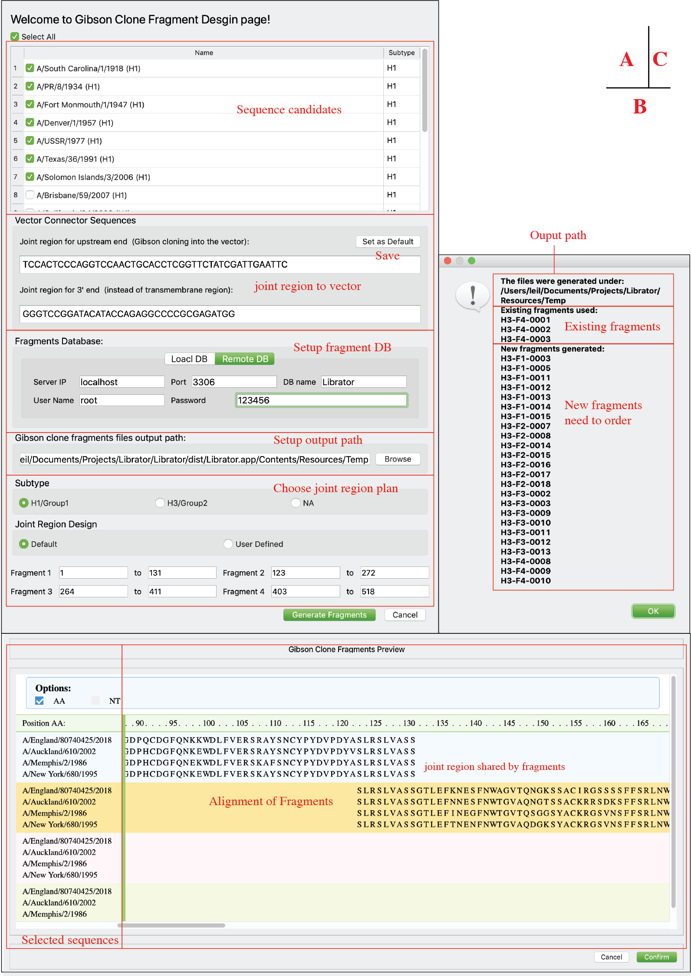

### Generate Gibson Clone fragments for any sequence

Beside HA/NA sequences, Librator also allows users to split any of their sequences into fragments. Users can use this function for some frontier and novel research, e.g. COVID-19.

Users can click *GibsonClone*-> *GibsonClone for single sequence* in *menu.* Users can view their sequence and add at most 12 joint regions (where to split the sequence) to their sequence. Then users can preview the fragment products under current design. After that, users can setup upstream connector sequence and downstream connector sequence and output path.

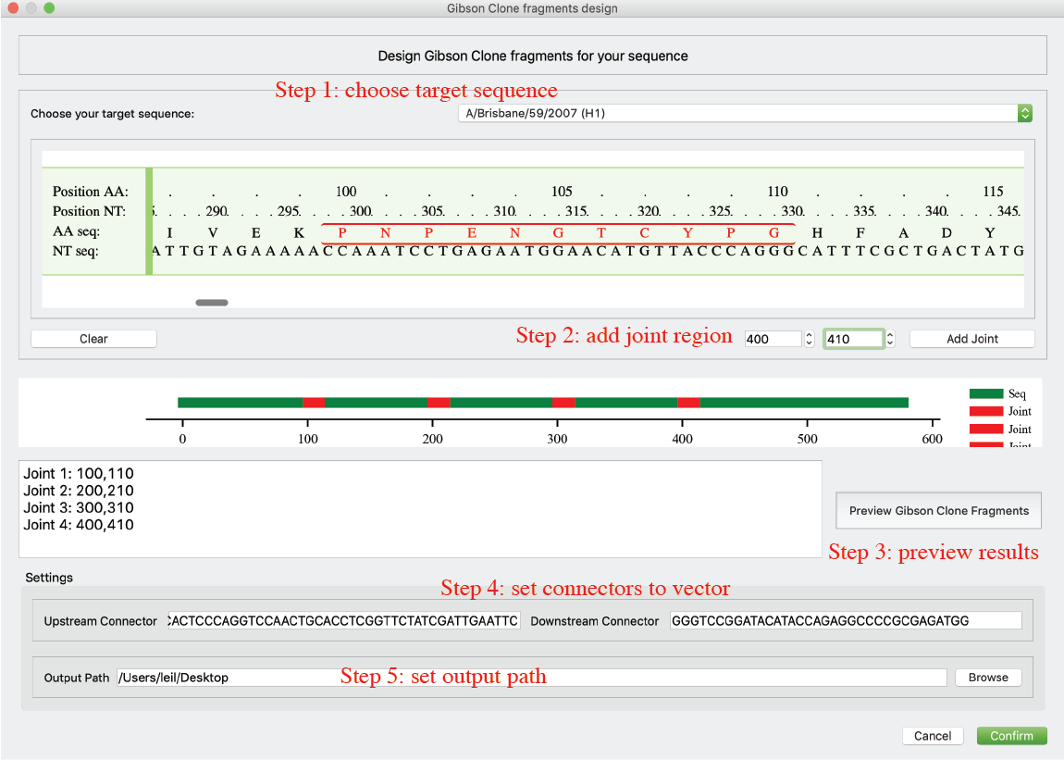

### Identify possible key residues from two groups of sequences

Librator allows users to identify possible key residues from two groups of sequences. This function could be helpful in the case of identifying key residues that potentially responsible for antigenic change or antibody binding.

Users can click *Tools-> Identify key residues* in *menu*. Users can double click sequence names on the left panel to add them into positive group or negative group to the right. Users can click the corresponding arrow to change the destination (green arrow indicates current destination). Users also can double click sequences on the right panel to remove them from current panel. After that, users can click ‘Identify possible key residues’ button to run analysis. The importance of residues is quantified and ranked by numerical score, which indicates the difference of amino acid composition between two groups. All residues will be listed in a table and be sorted by the score (inverse order). Multiple sequence aliment will also be popped up for users to investigate the details.



# Contact

For comments and feedbacks please E-mail Lei Li([leil@uchicago.edu](mailto:leil@uchicago.edu)) or Patrick C. Wilson([wilsonp@uchicago.edu](mailto:wilsonp@uchicago.edu))